## CHAPTER 5

## TECHNICAL SPECIFICATION

## Hardware Specification:

1. **Ram:** 4GB.
2. **Hardrive Storage Needed:**40GB.
3. **Other Hardware Requirements :**None.

## Platform:

1. **Supported Operating System:** Windows XP and above LINUX and MacOS is compatible.
2. **Programmer Server:** Wamp 2.5, Apache Server 2.4.9.

## Programming Language

1. **Mark-up Language:**HTML5.
2. **Programming Language:** PHP5.5.12
3. **Scripting Language:** Java Script ES2015.

## Technical Support:

1. **Front-End:** PHP5.5.12
2. **Back-End:** MySQL5.6.17
3. **IDE:** Sublime Text 3
4. **UML Tools:** Draw.io 14.9.6
5. **SRS Tools:** Microsoft Word 2016.

## DESIGN LAYOUT

**Registration Page: -**

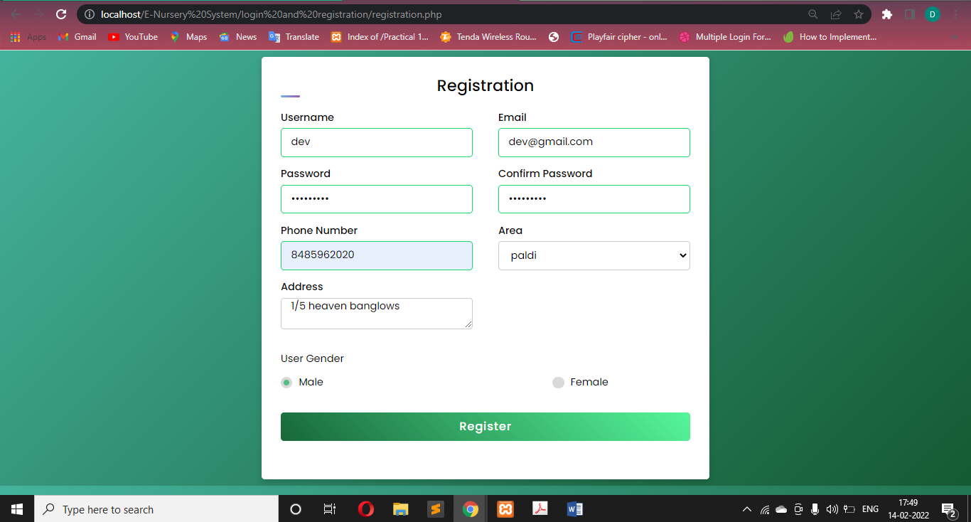

# [Figure 6: Registration page]

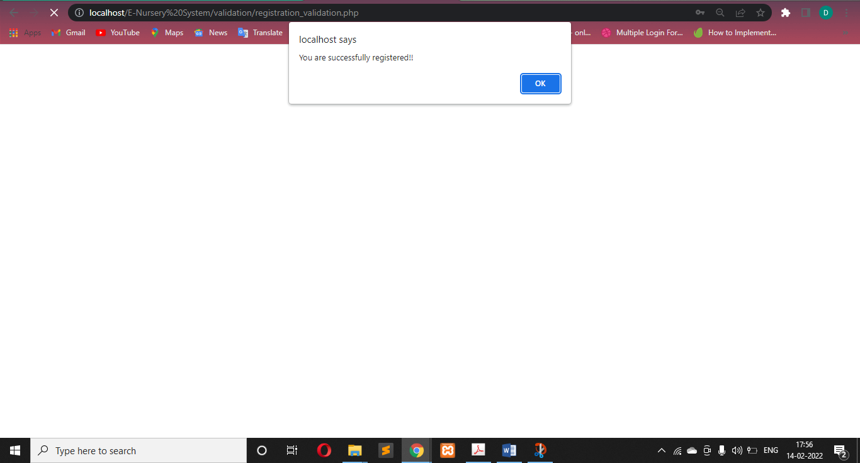

# [Figure: Registration successfully]

## Login page: -

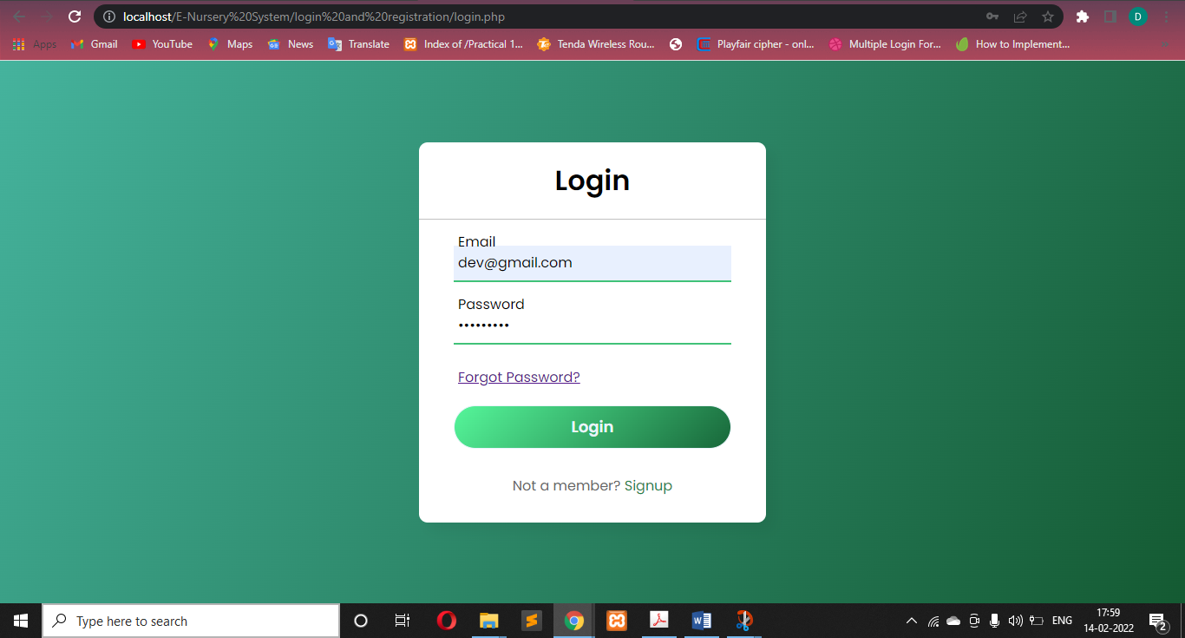

# [Figure : Login Page]

## Home page: -

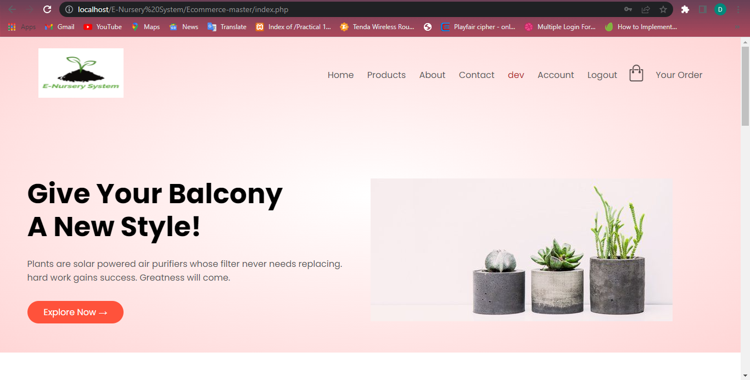

# [Figure: Home Page Top]

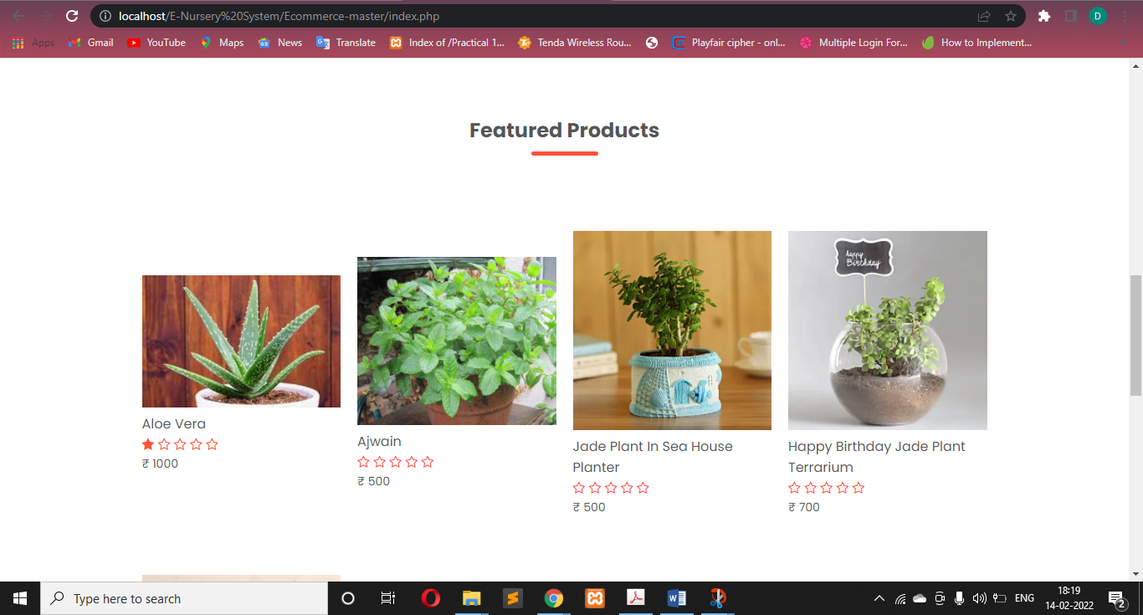

# [Figure: Home Page Bottom]

## Product Page: -

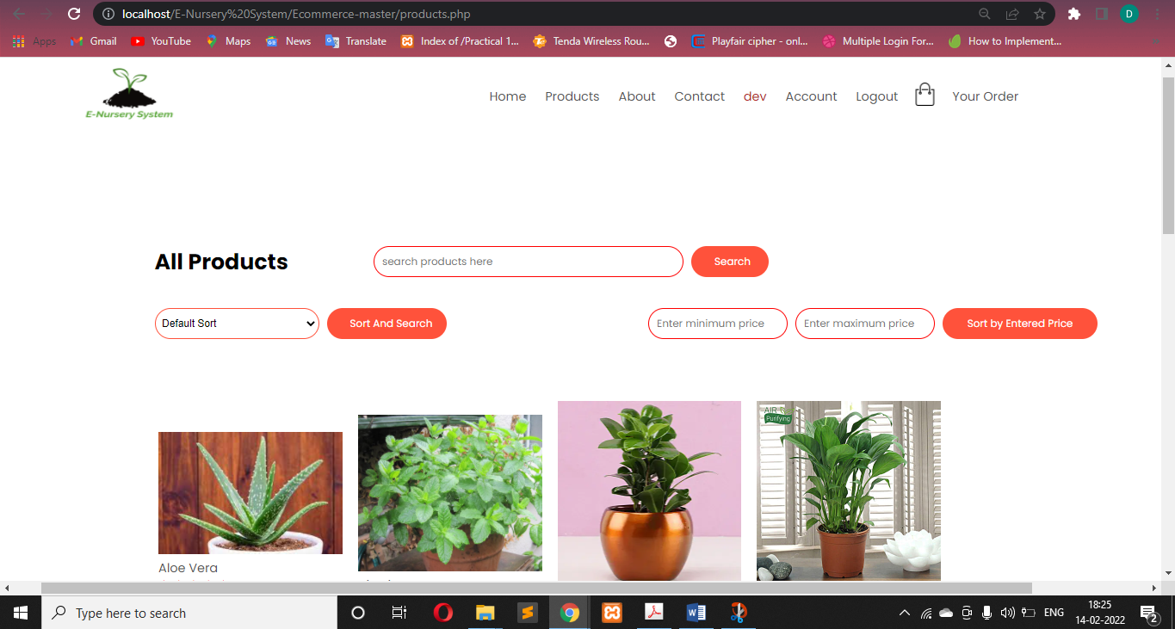

# [Figure: Home Page Bottom]

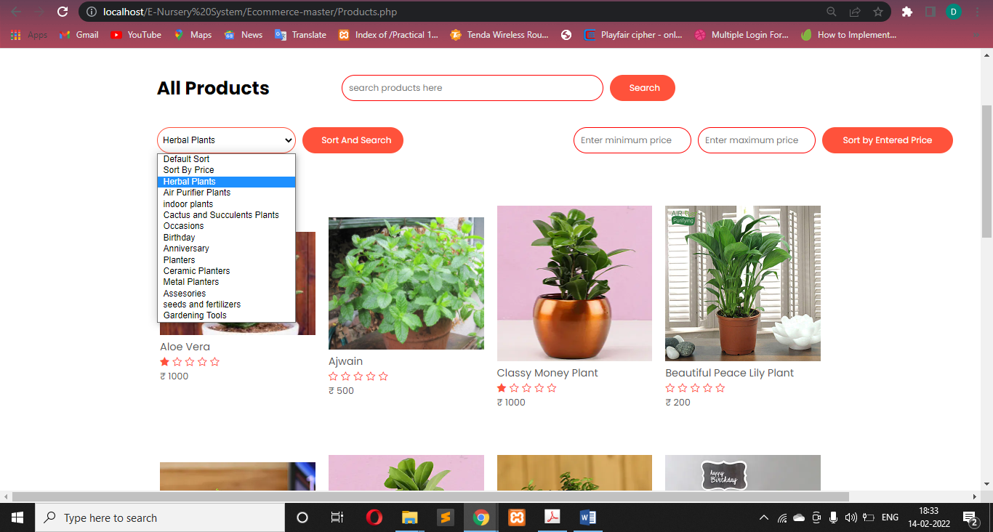

# [Figure: Product categories and sorting menu]

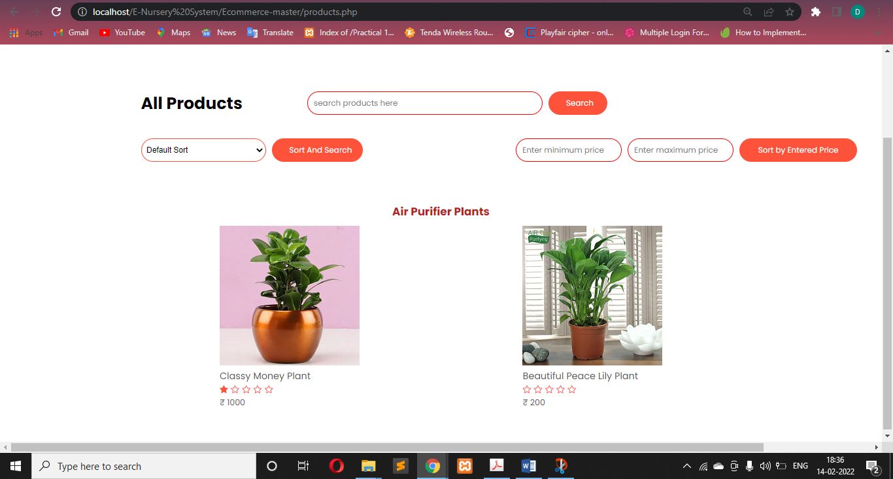

# [Figure: Product categories and sorting menu]



# [Figure: Sorted List]

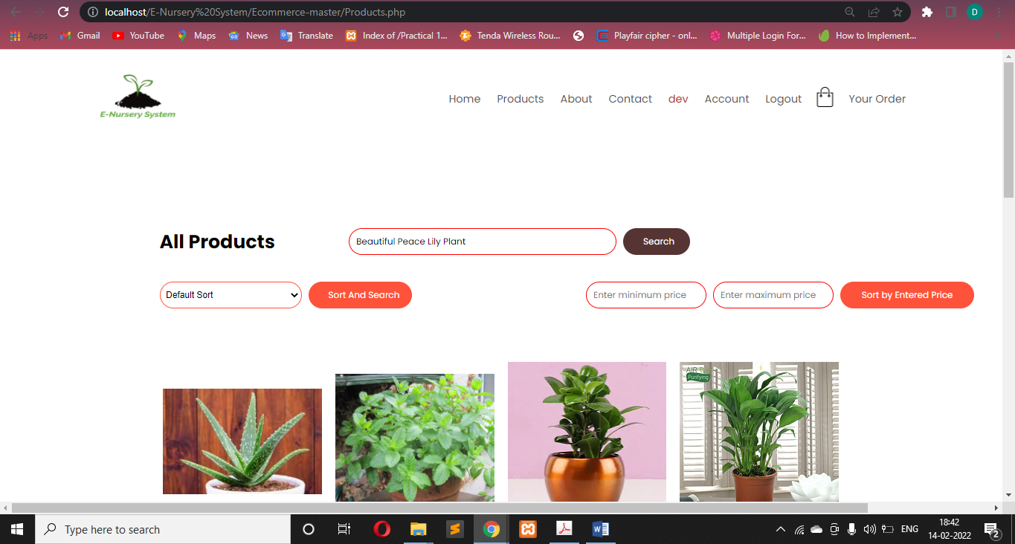

# [Figure: Searching Product]

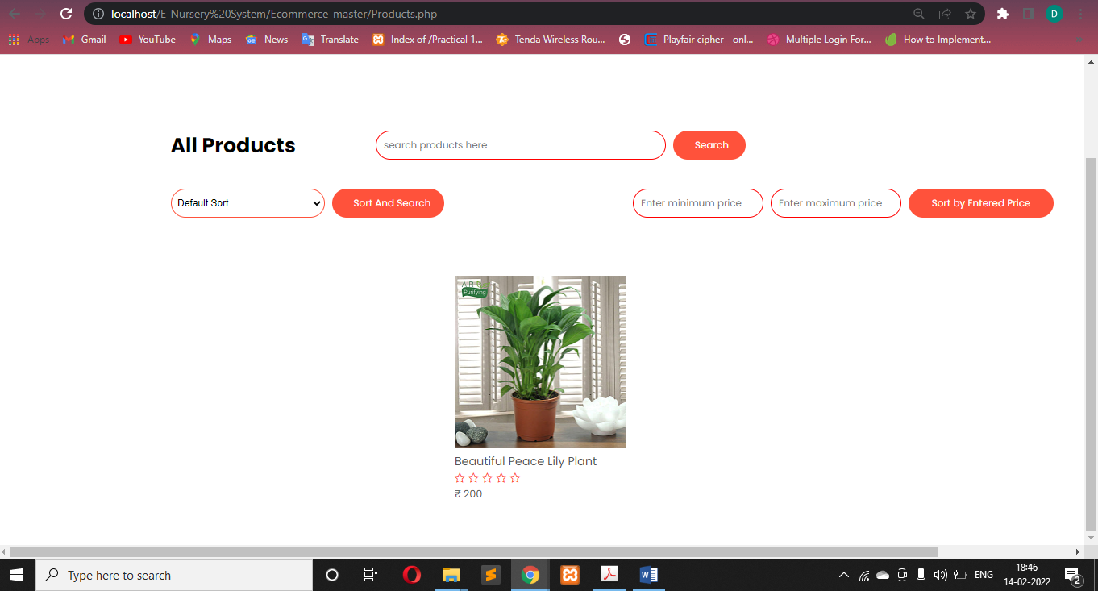

# [Figure : Searched Product]

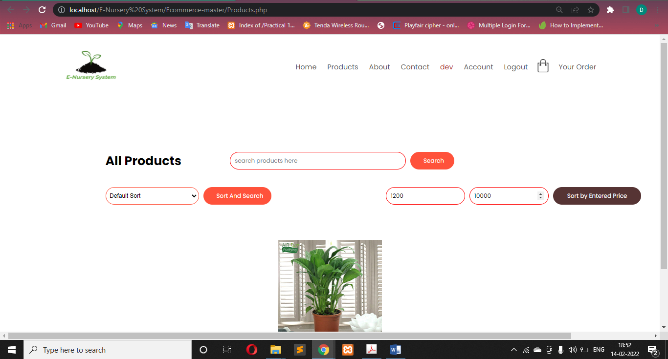

# [Figure: Sorting Product by pricing]

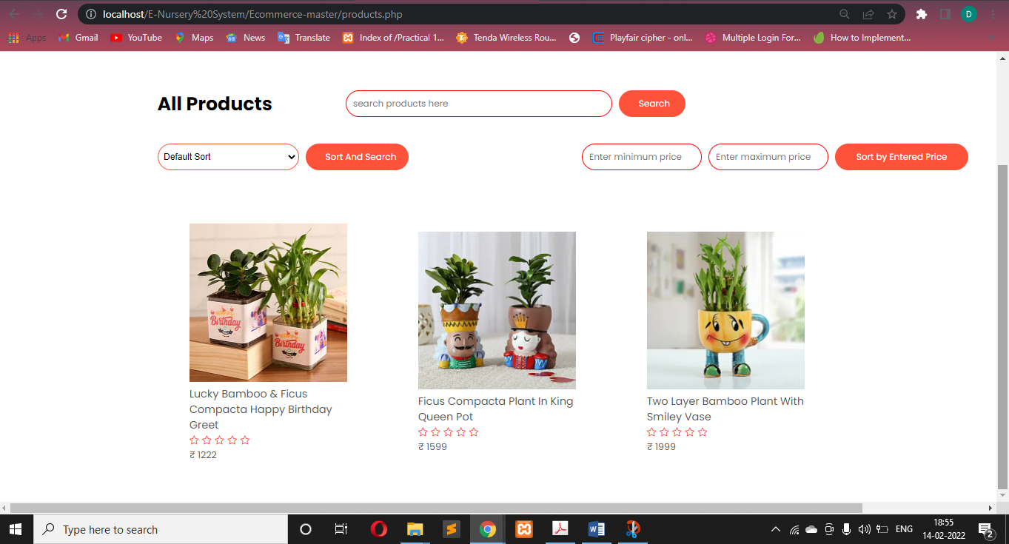

# [Figure: Sorted Product by pricing]

## Product Details: -

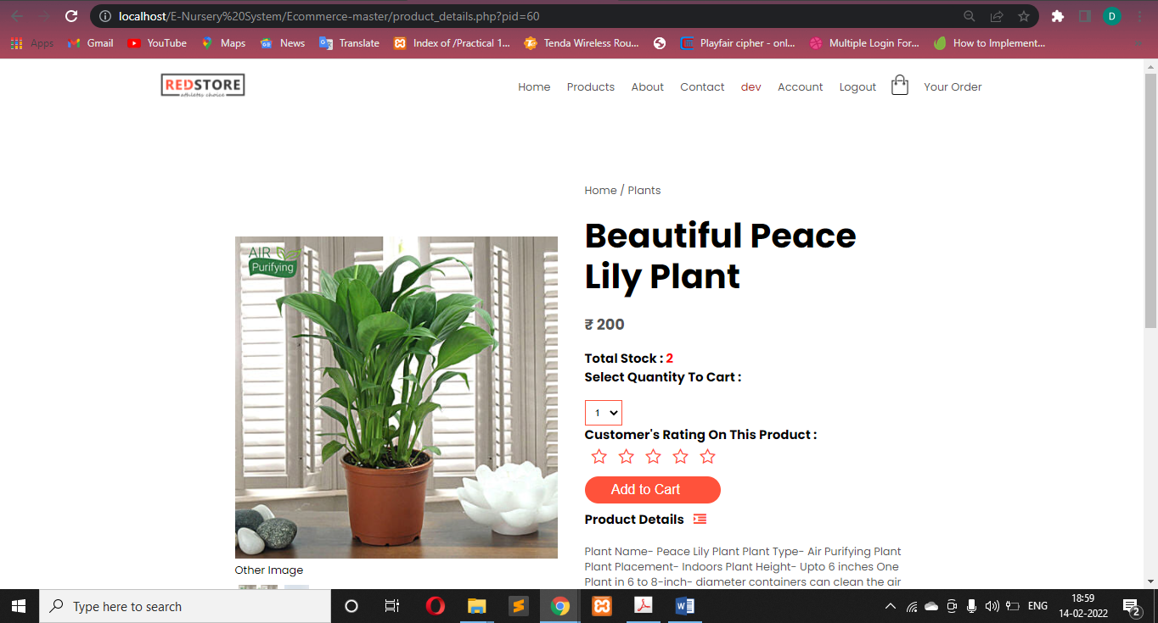

# [Figure: Product Details]

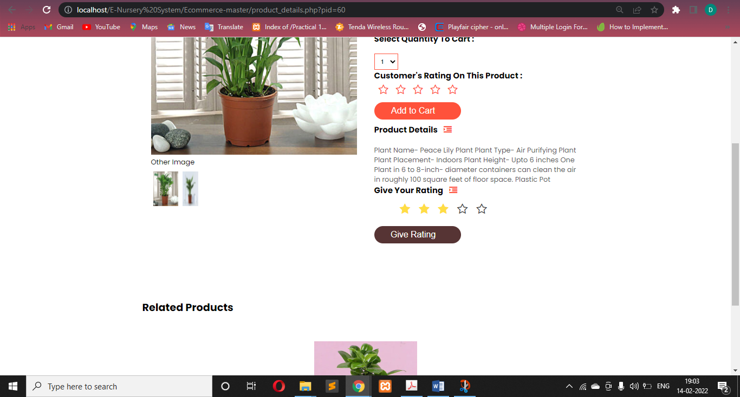

# [Figure: Giving Rating]

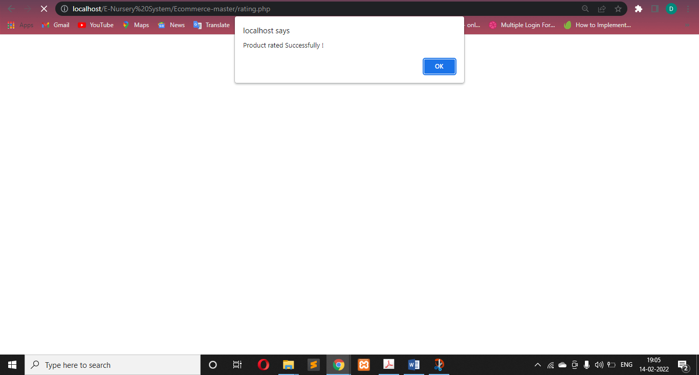

# [Figure: Rated Successfully]

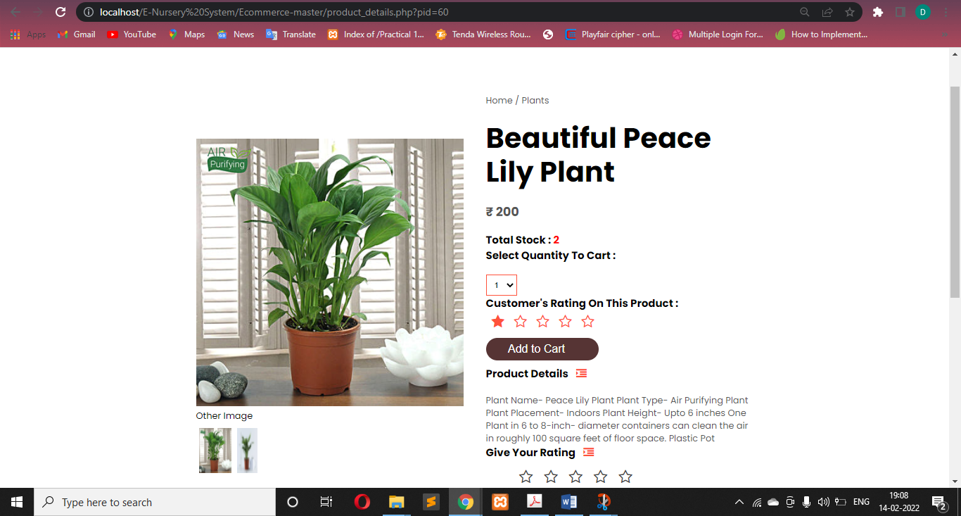

# [Figure: Add Product to cart]

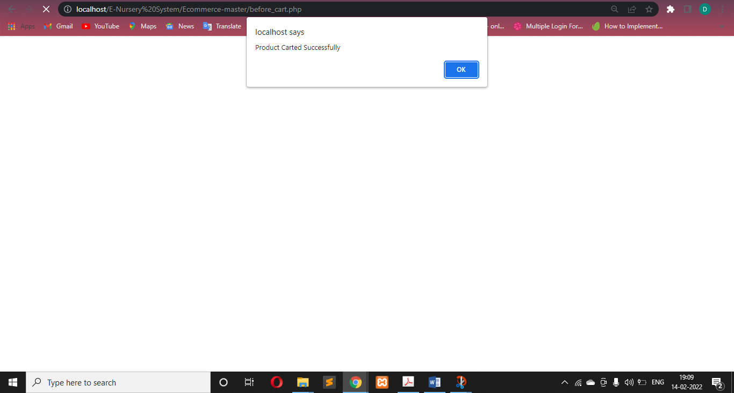

# [Figure: Product carted successfully]

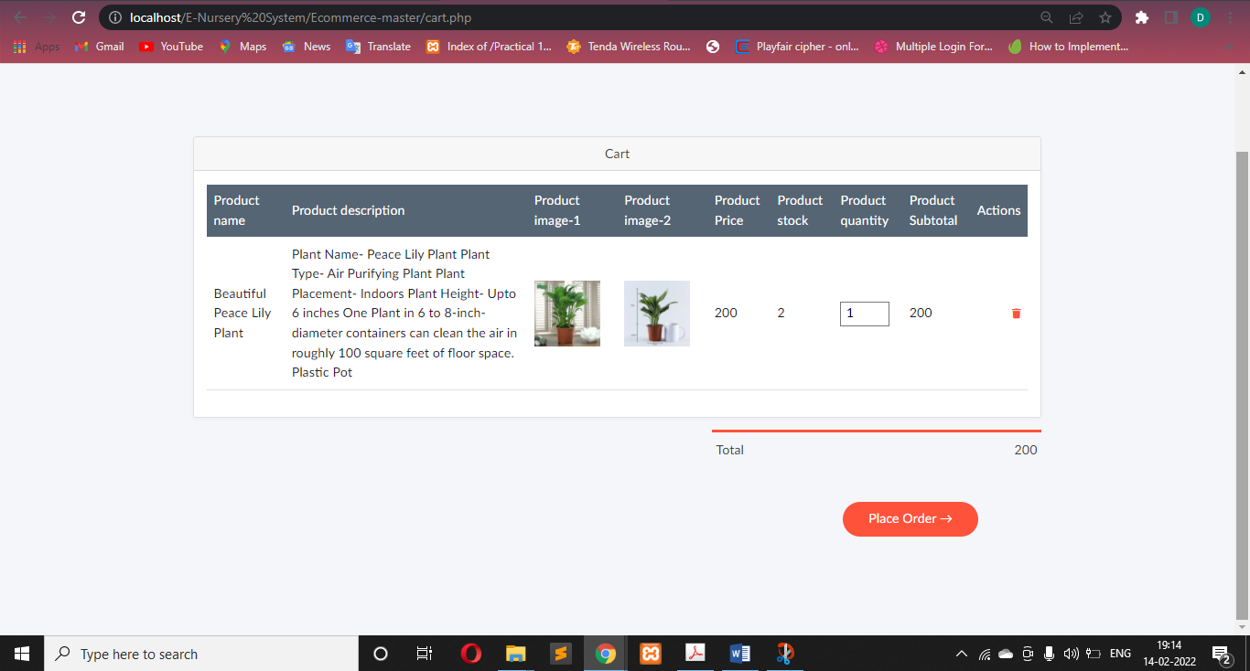

# [Figure: Cart]

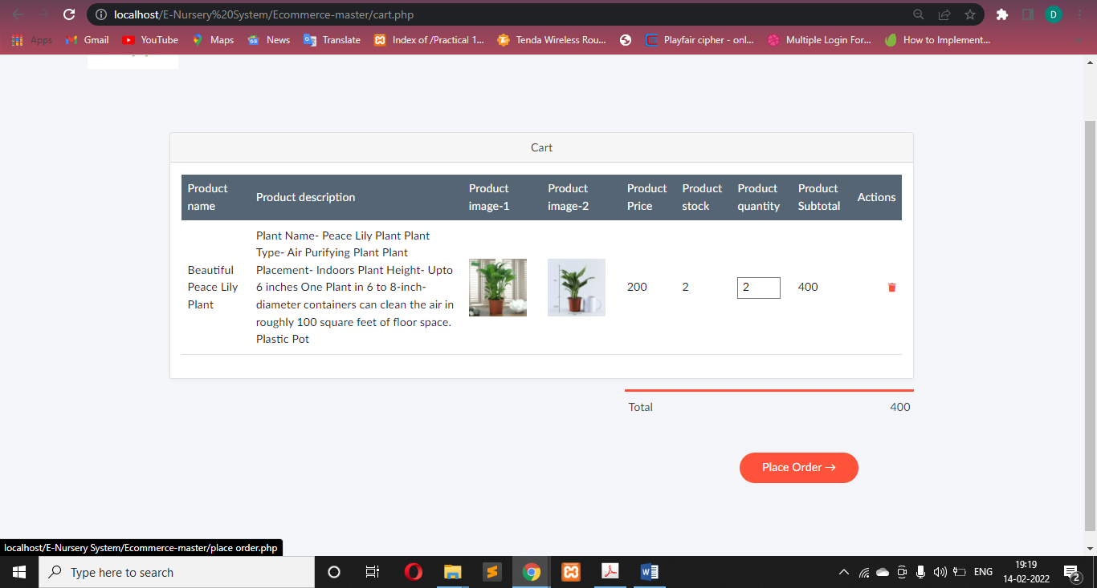

# [Figure: Place Order]

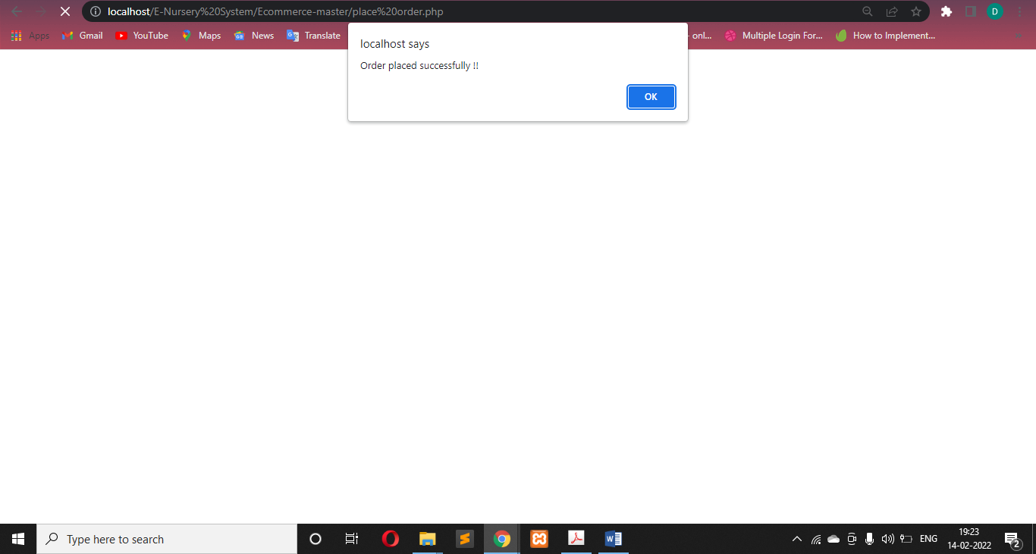

# [Figure: Order Placed Successfully]

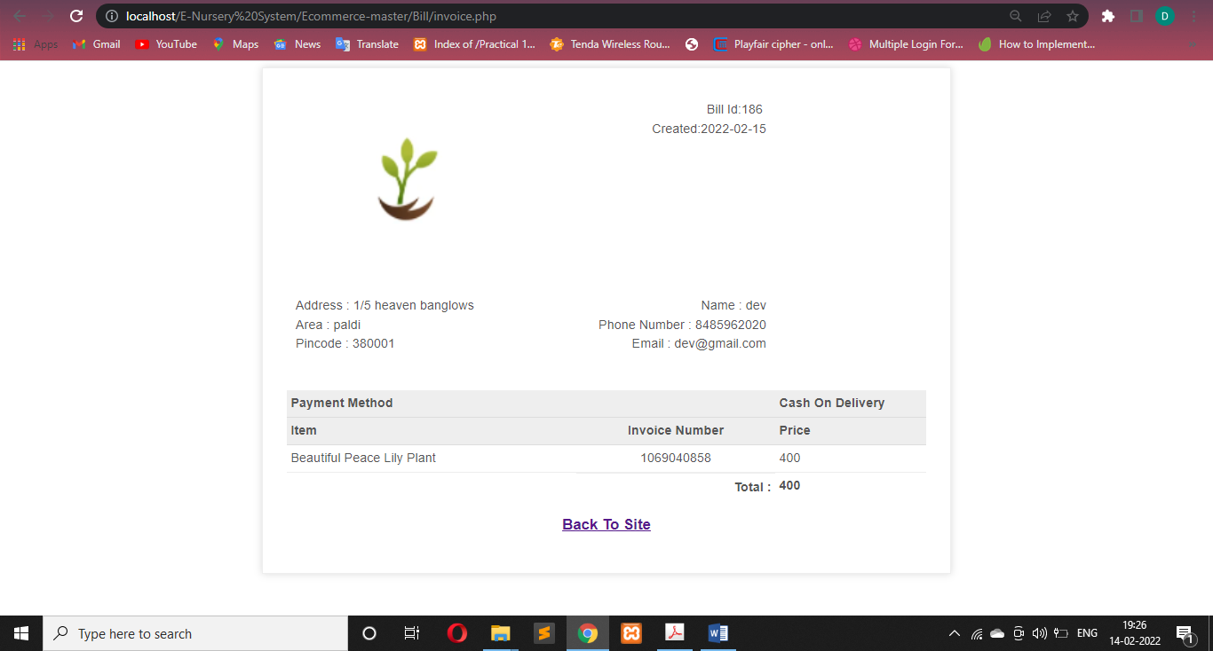

# [Figure: Bill of Orders]

## Your Order Page: -

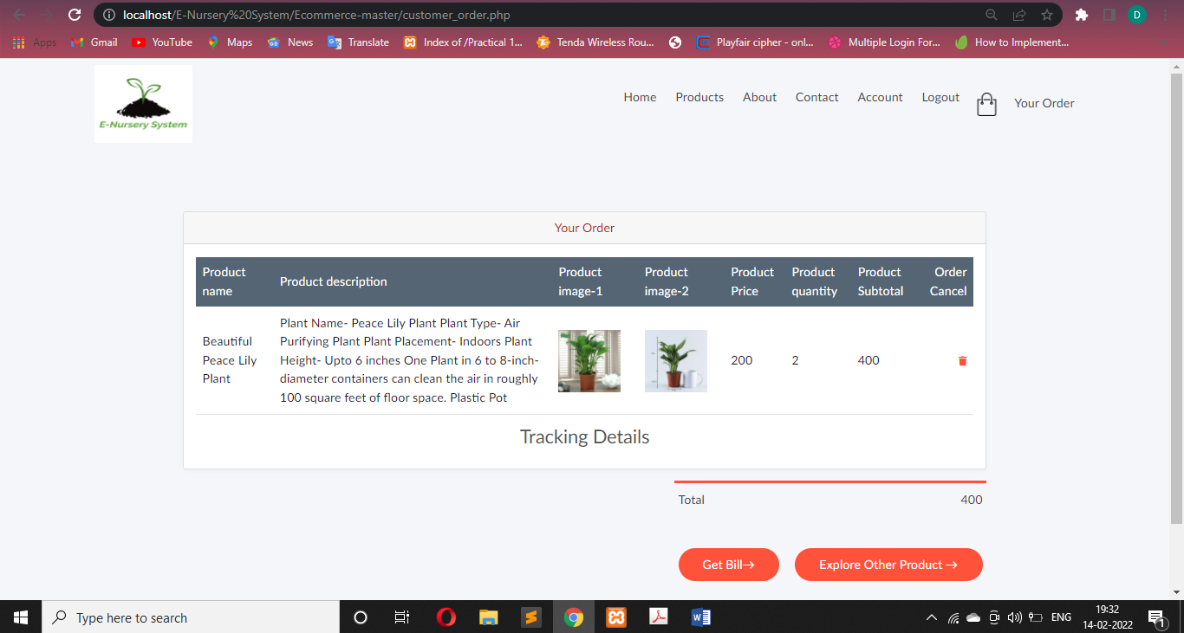

# [Figure: List of Orders]

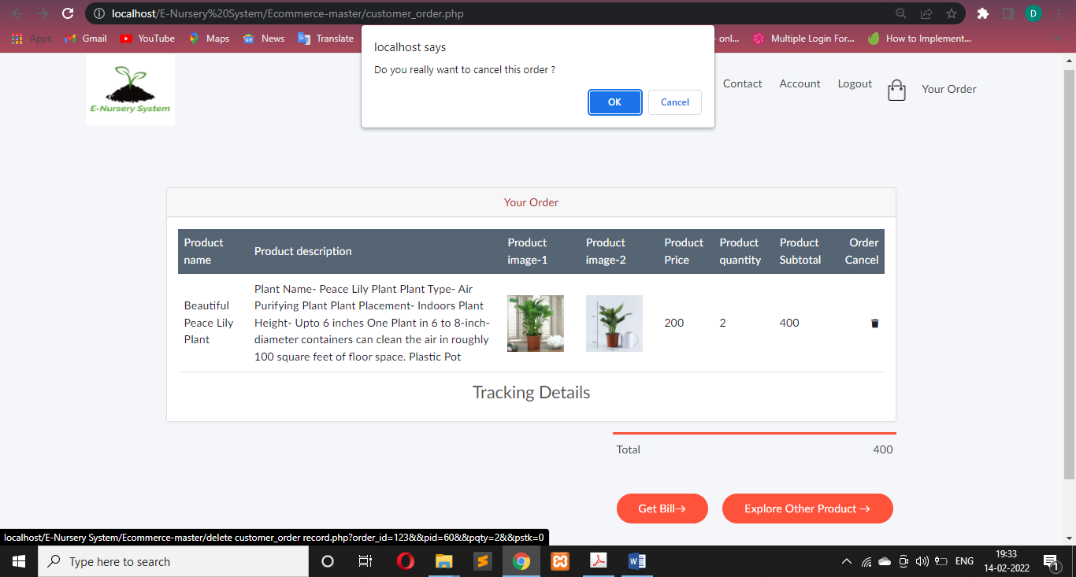

# [Figure: Cancelling Orders]

## Account Page:

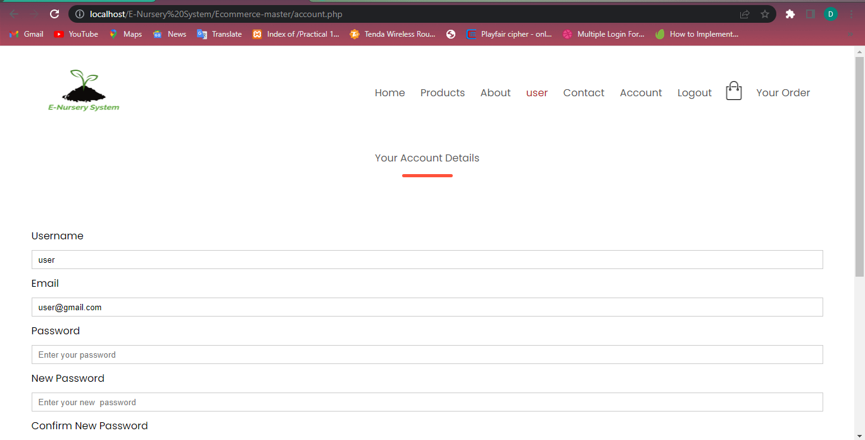

# [Figure: Account Page (Top)]

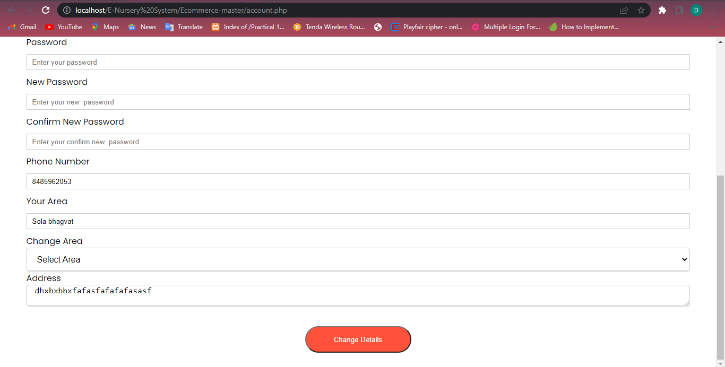

# [Figure: Account page(Bottom)]

## Demonstrate Changing Username:

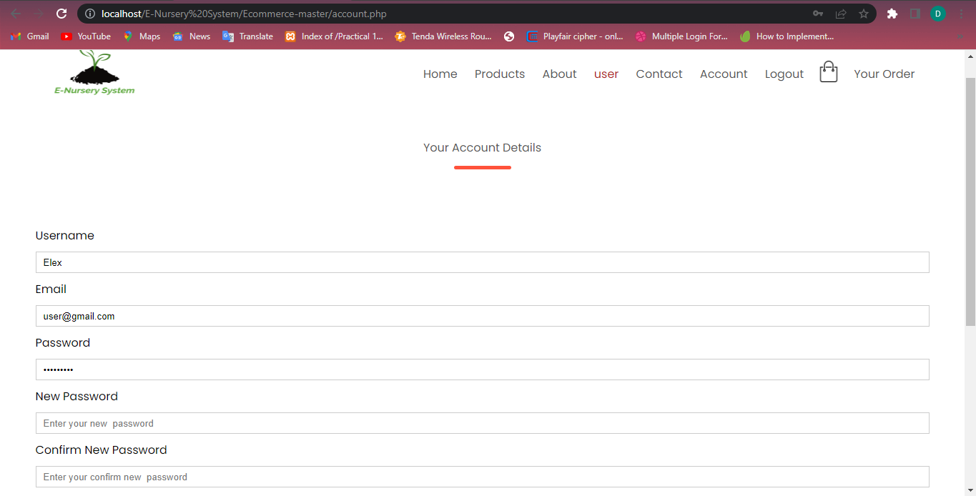

# [Figure: Changing username (user to Elex, for update password will required)]

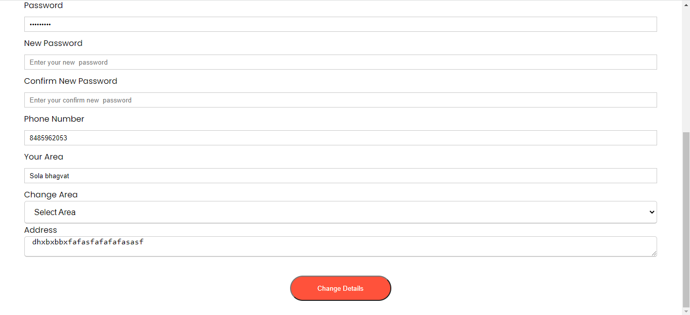

# [Figure: Click on Change Details]

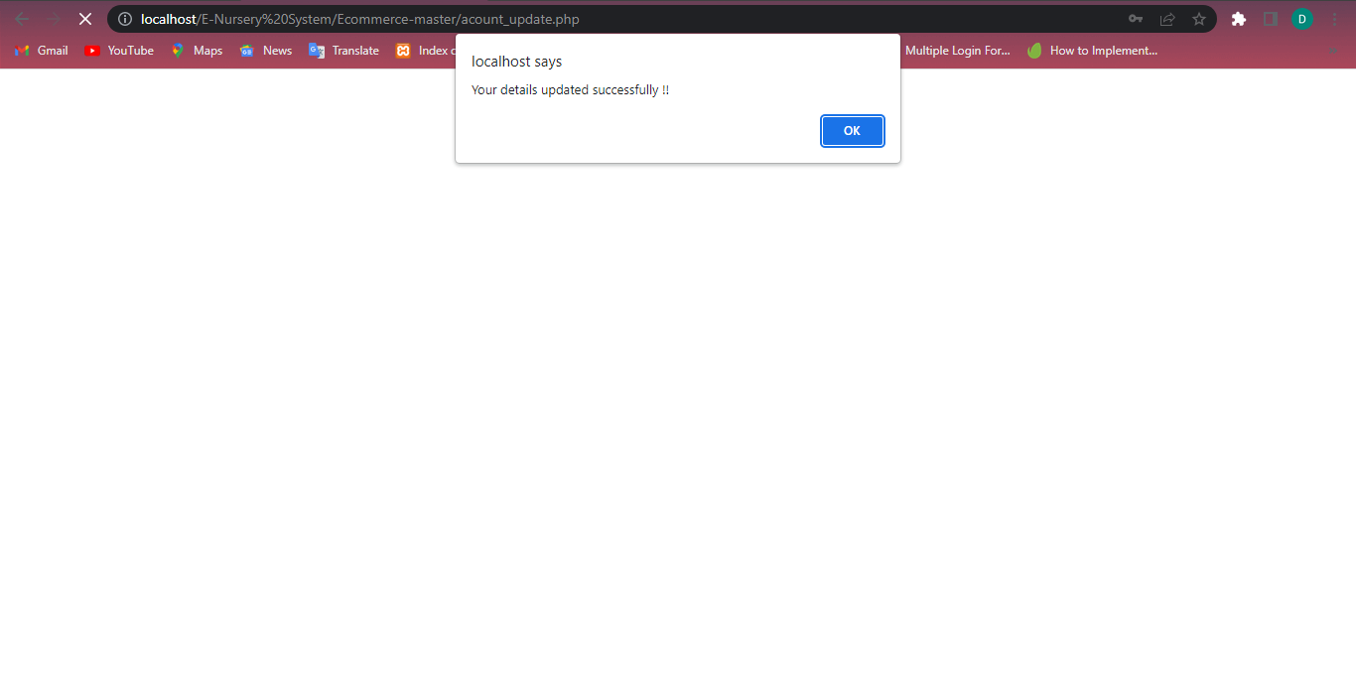

# [Figure: User name Changed]

**Admin Login:**

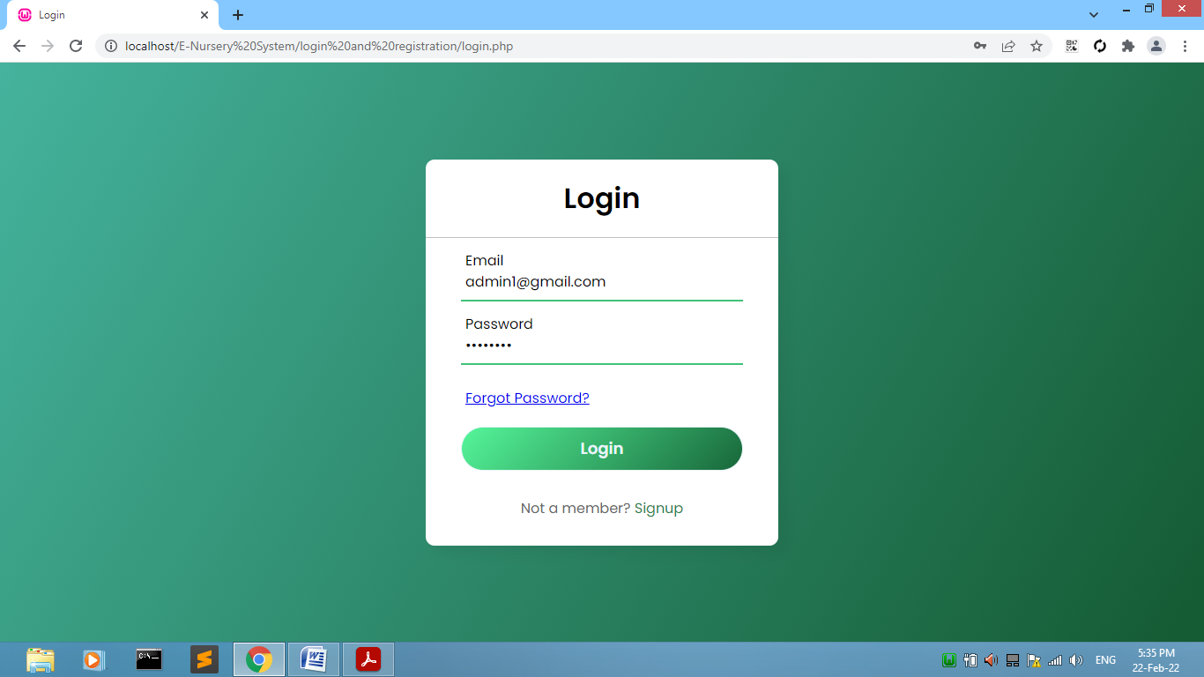

# [Figure: Admin Login]

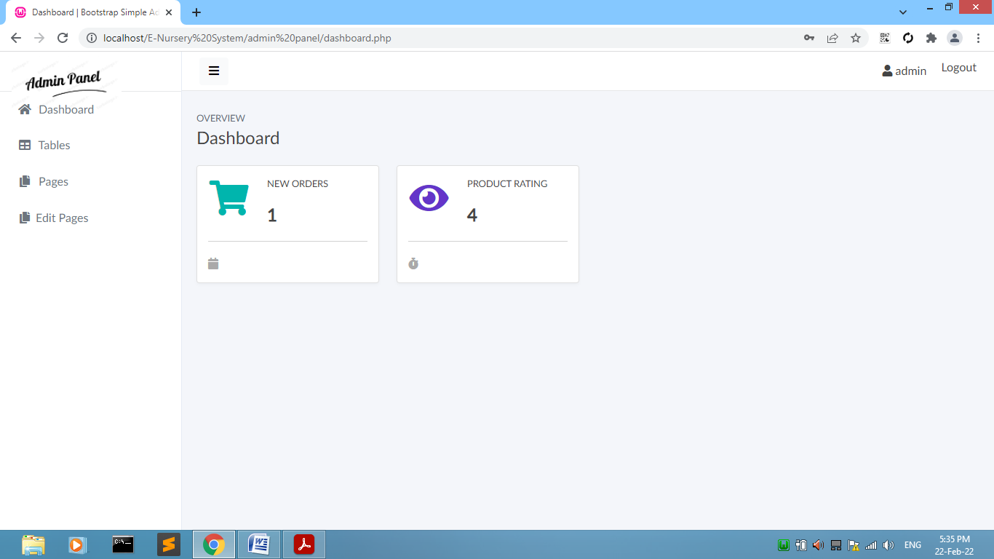

# [Figure: Admin Dashboard]

**Category Page:**

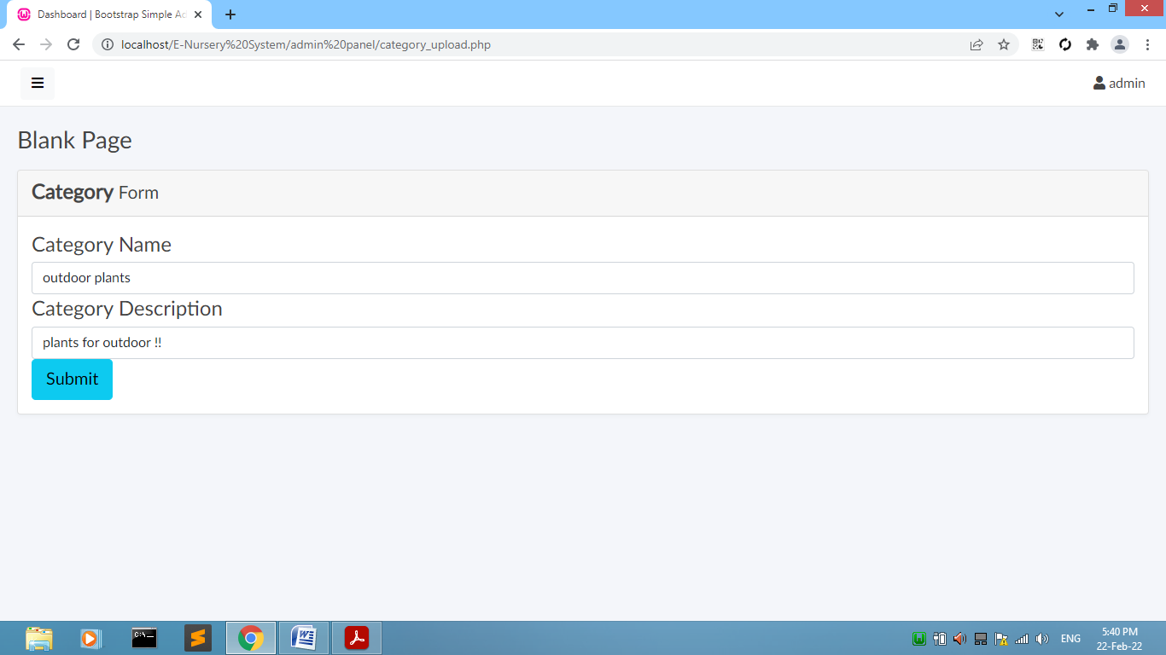

# [Figure: Add Category]

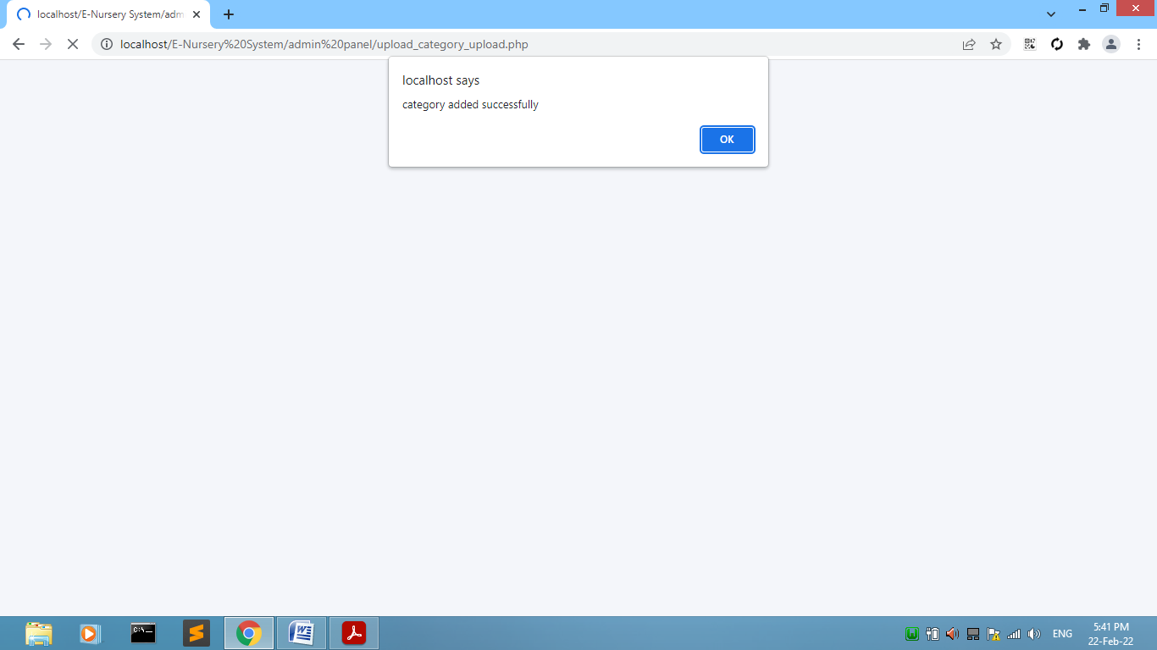

# [Figure: Category Added Successfully]

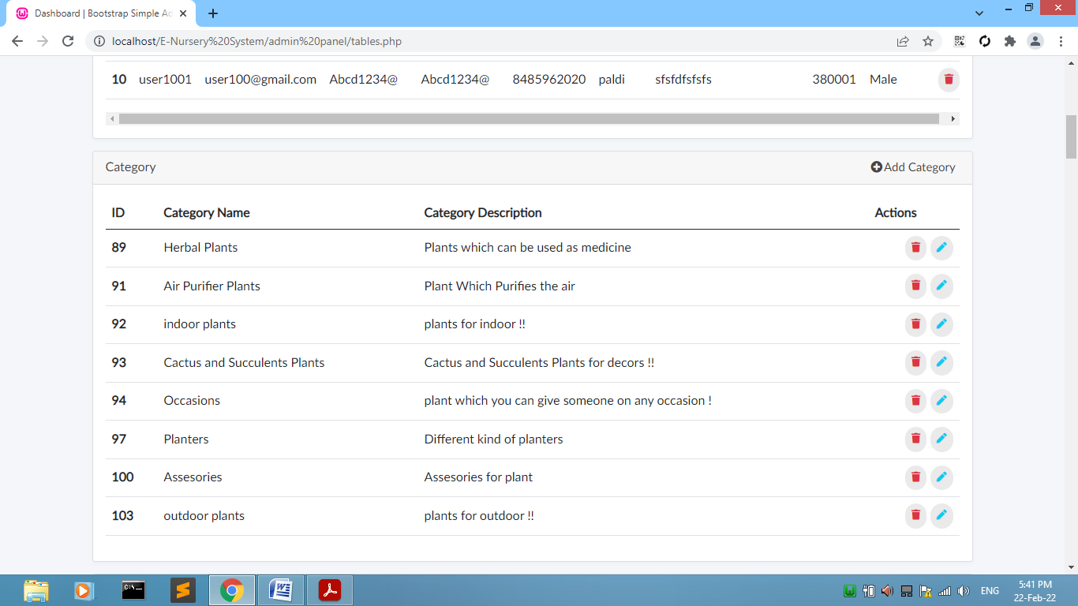

# [Figure: Category Display]

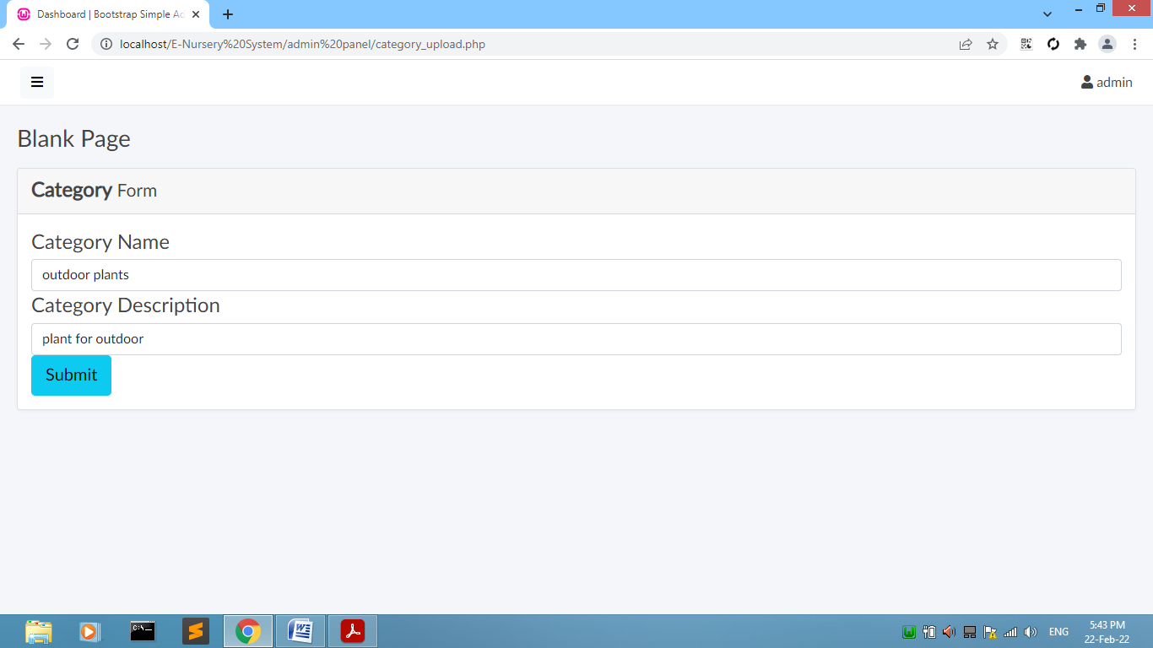

# [Figure: Re-Enter Category Name or Description]

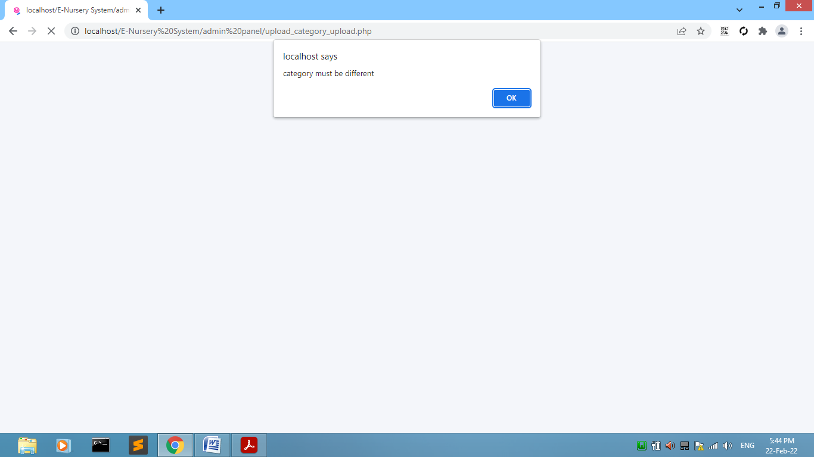

# [Figure: Category Validation]

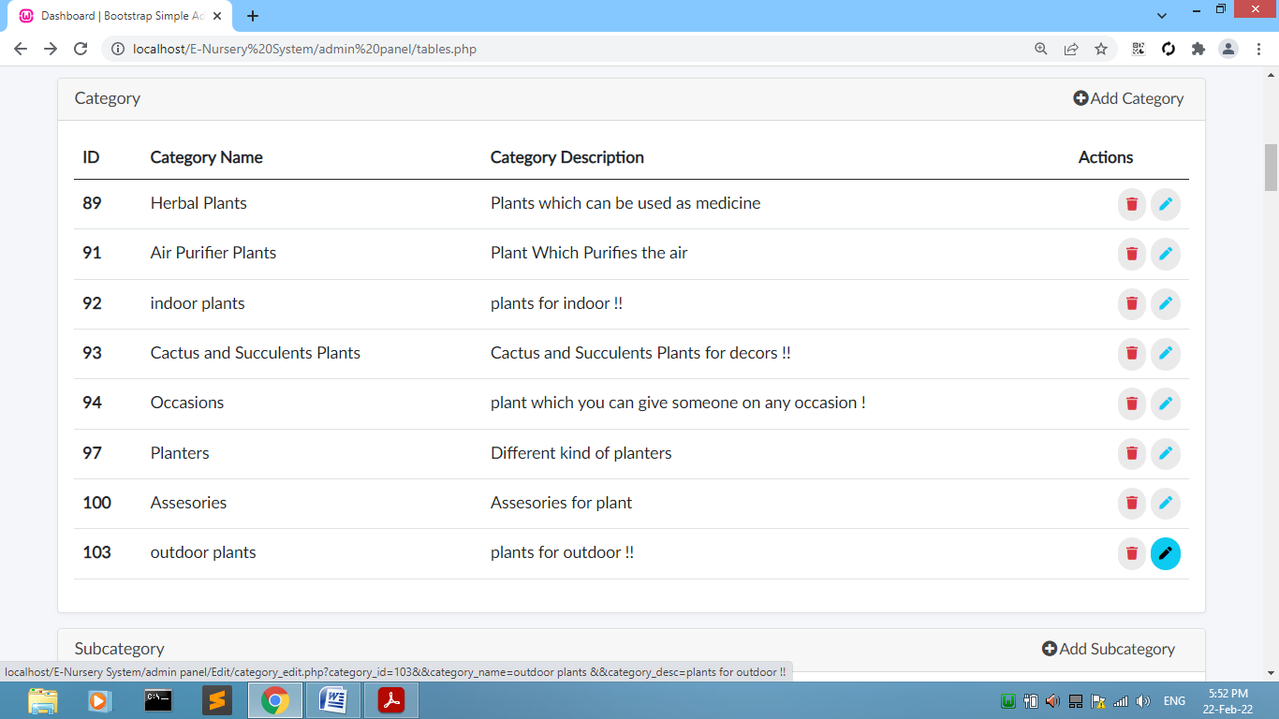

# [Figure: Category Edit]

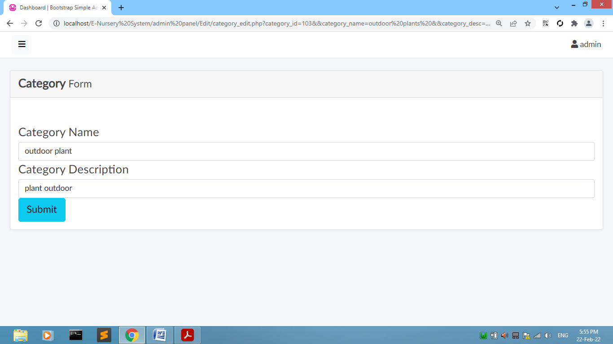

# [Figure: Edit Category Name or Description]

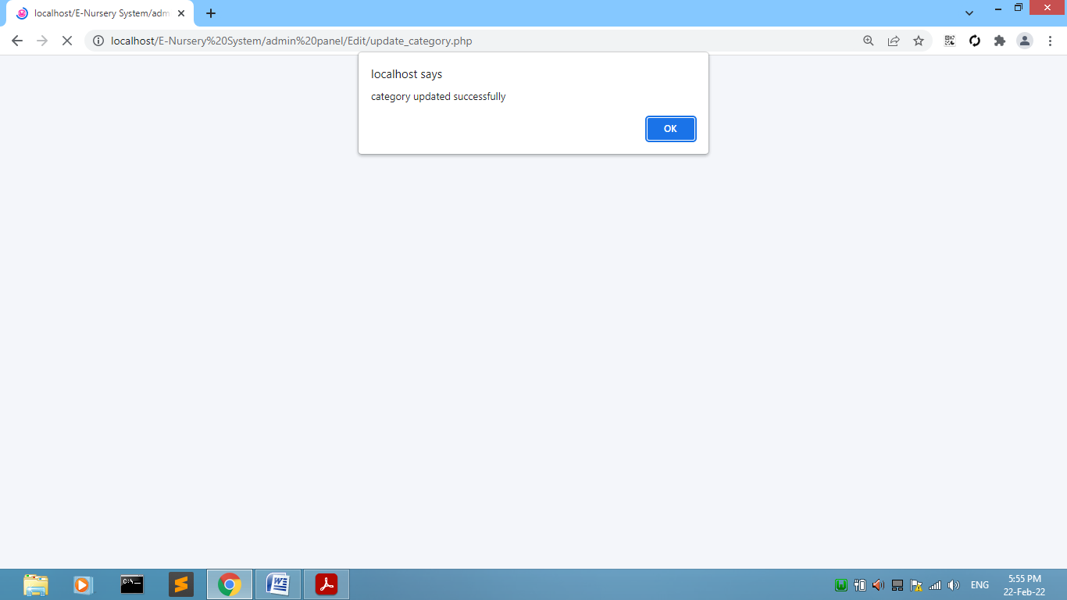

# [Figure: Category Edited]

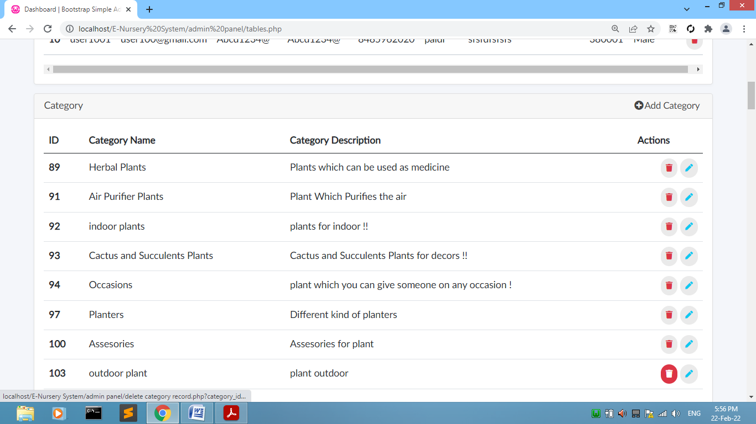

# [Figure: Display Category Edited]

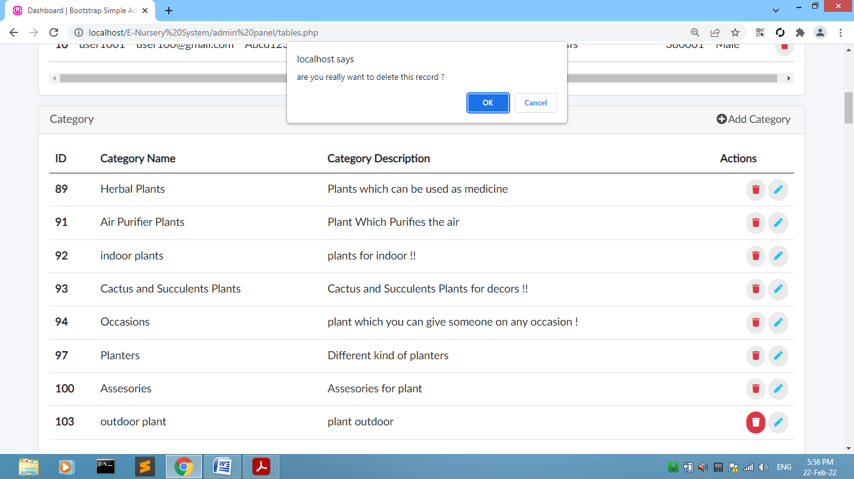

# [Figure: Category Delete]

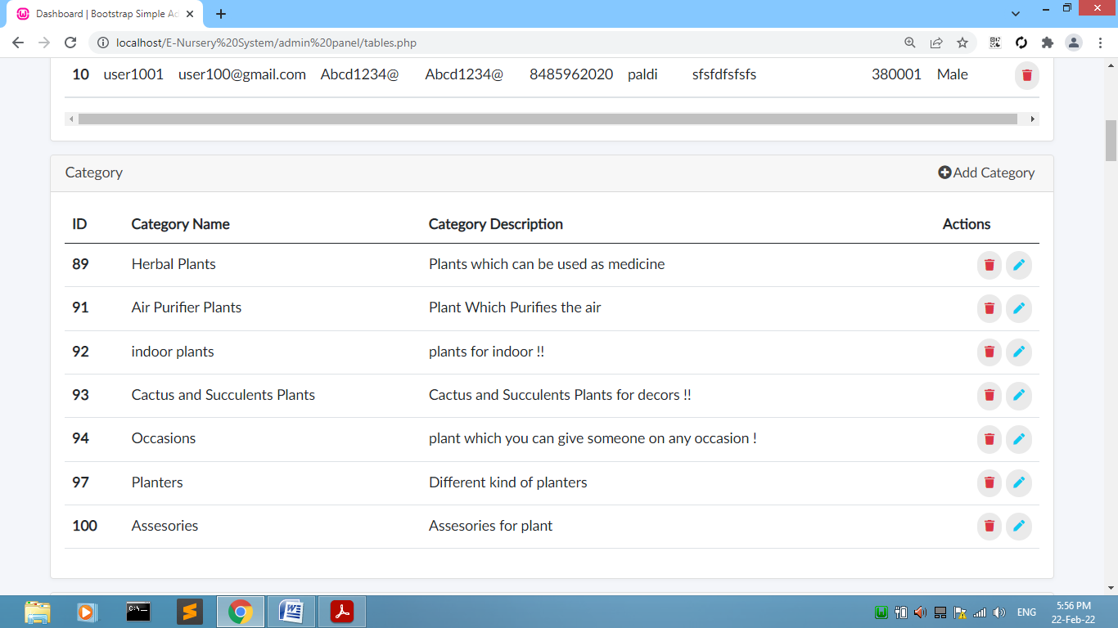

# [Figure: Category Deleted]

**Subcategory Page:**

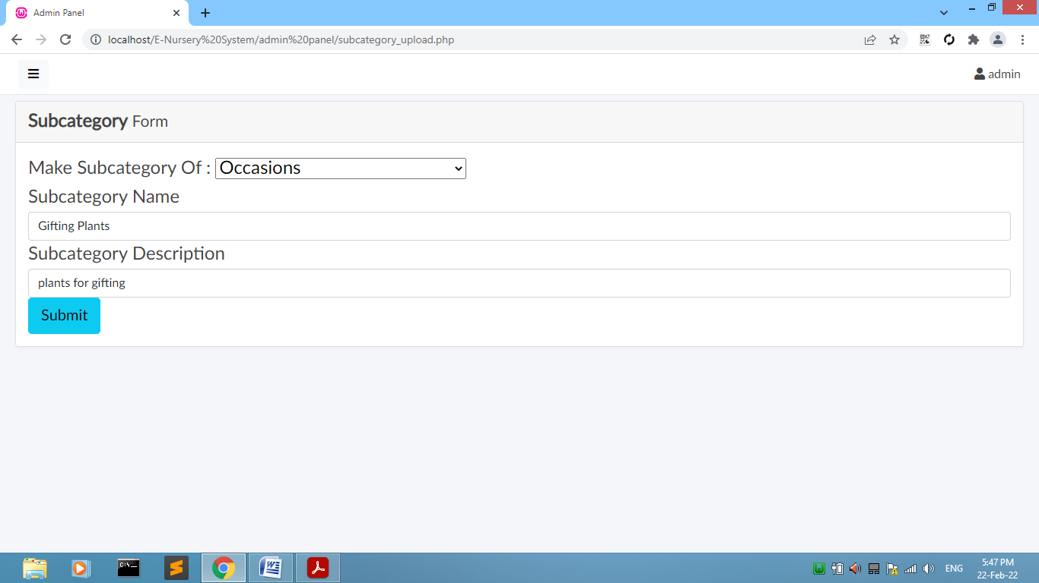

# [Figure: Add Subcategory]

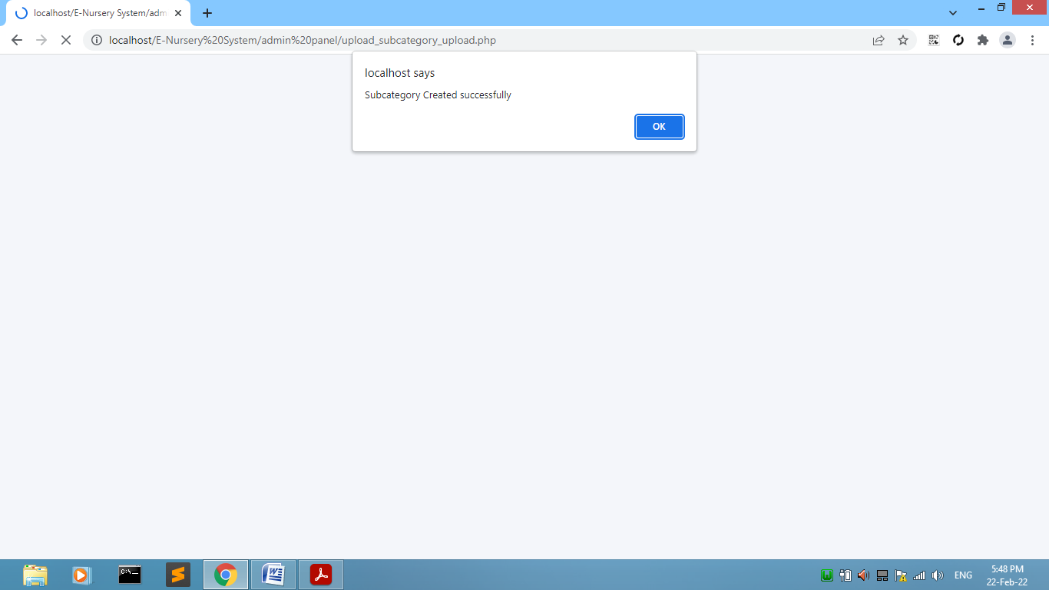

# [Figure: Subcategory Added Successfully]

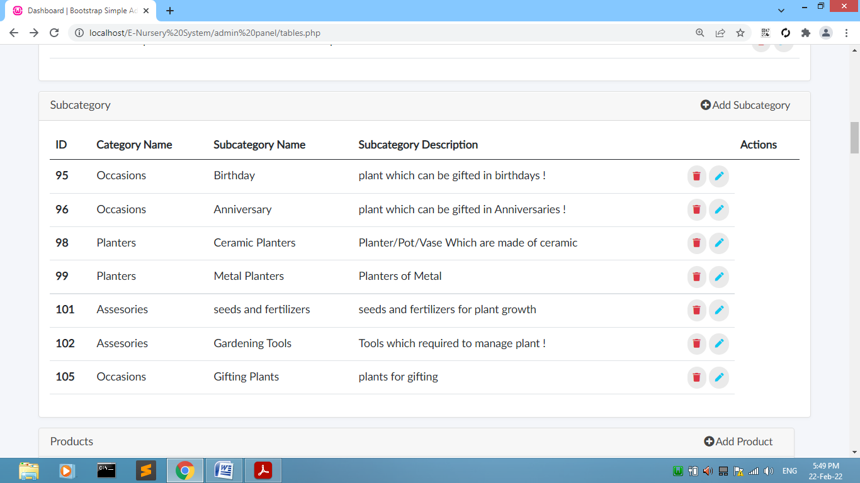

# [Figure: Subcategory Display]

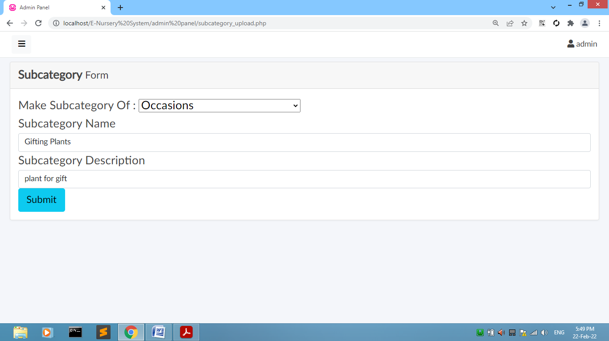

# [Figure: Re-Enter Subcategory Name or Description]

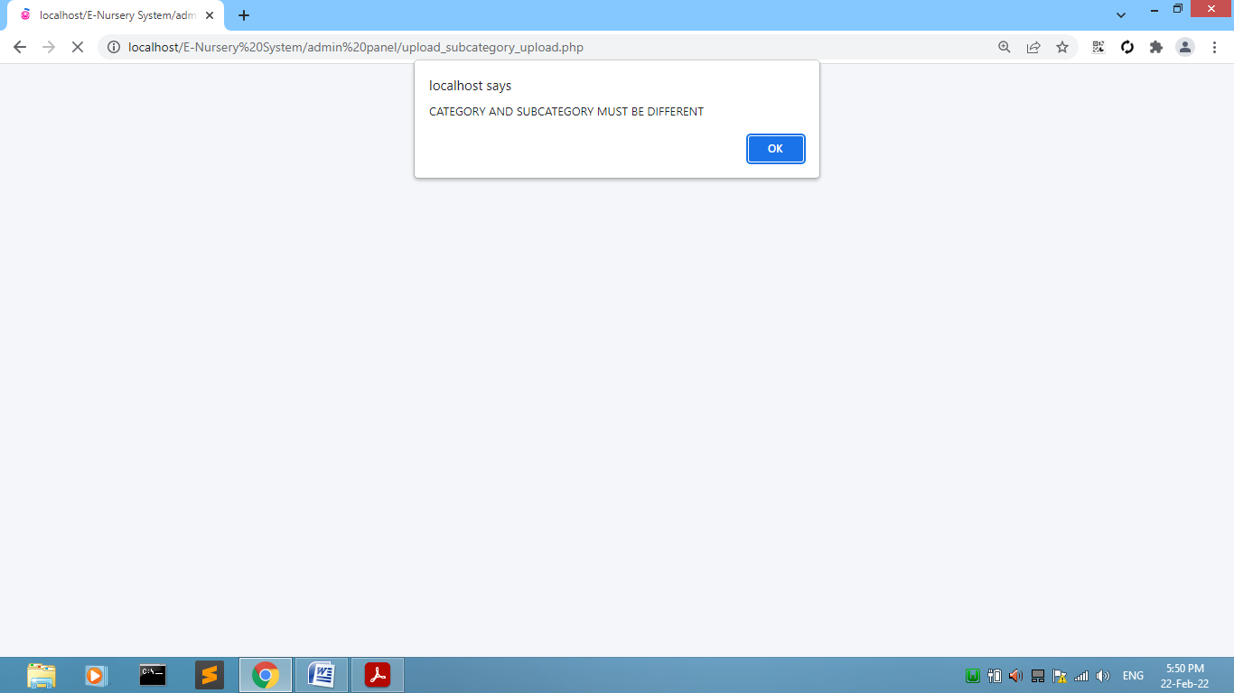

# [Figure: Subcategory Validation]

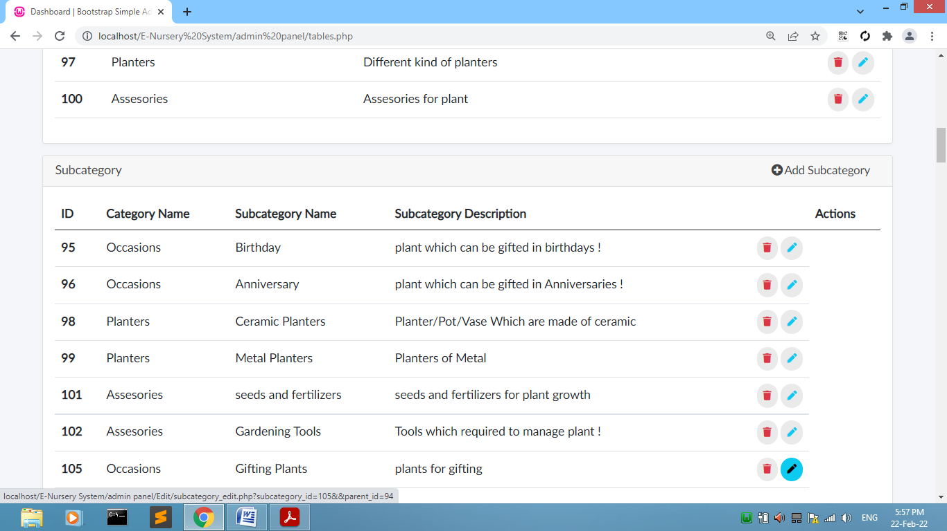

# [Figure: Subcategory Edit]

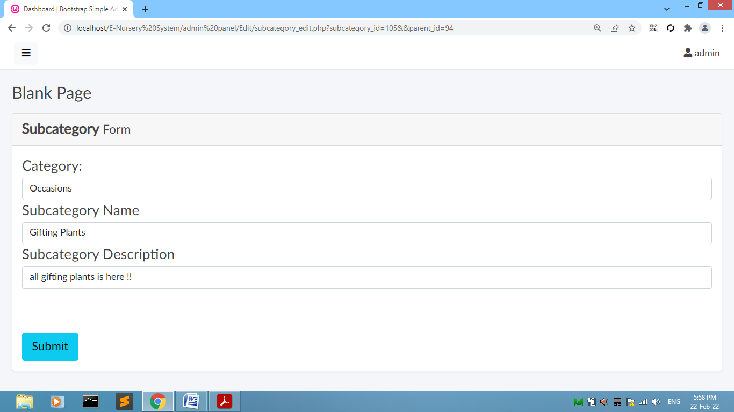

# [Figure: Edit Subcategory]

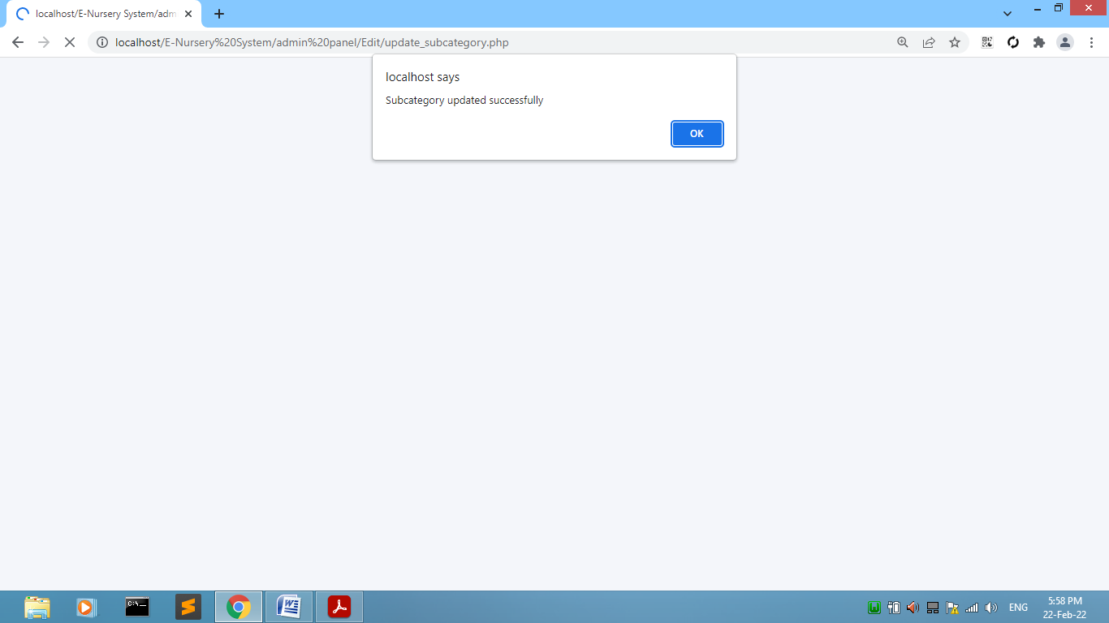

# [Figure: Subcategory Edited Successfully]

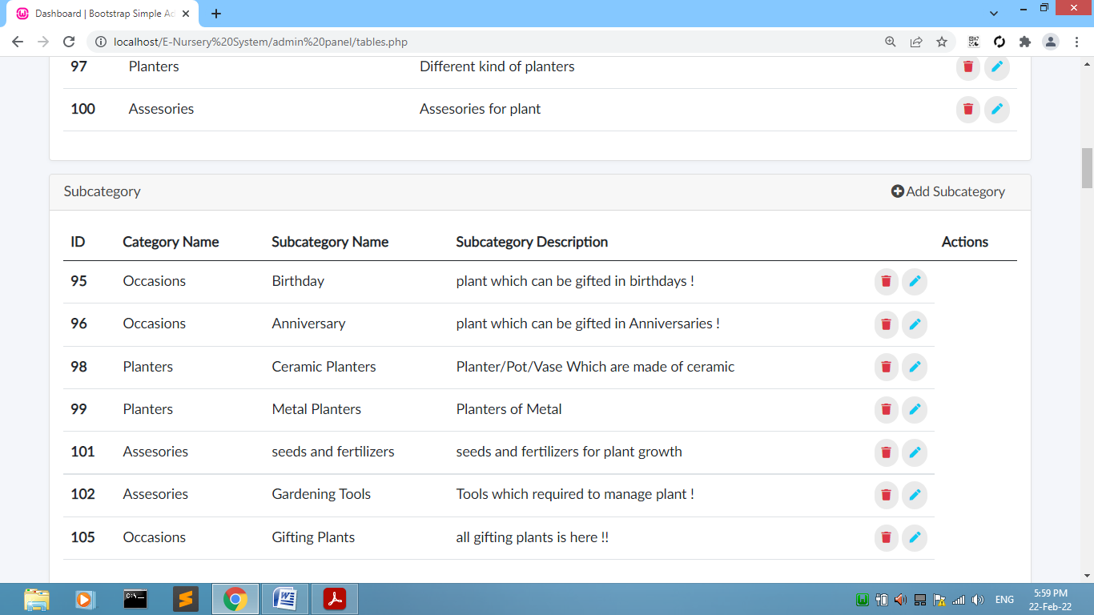

# [Figure: Display Subcategory Edited]

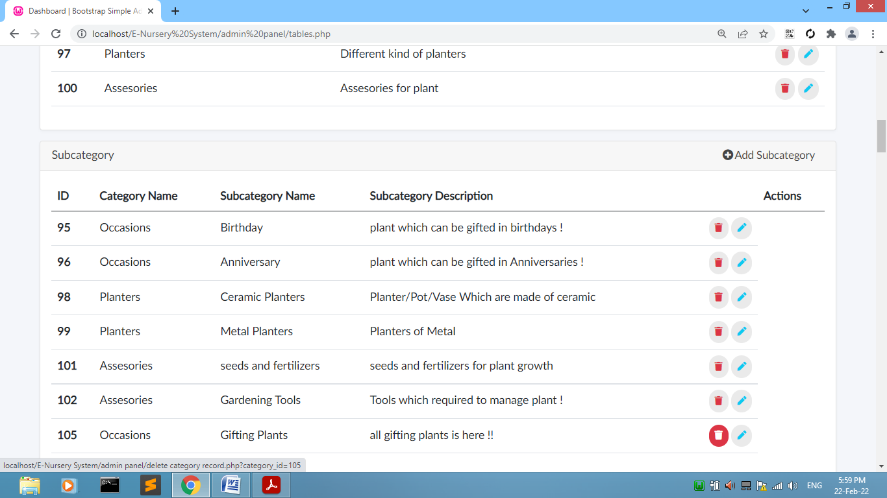

# [Figure: Subcategory Delete]

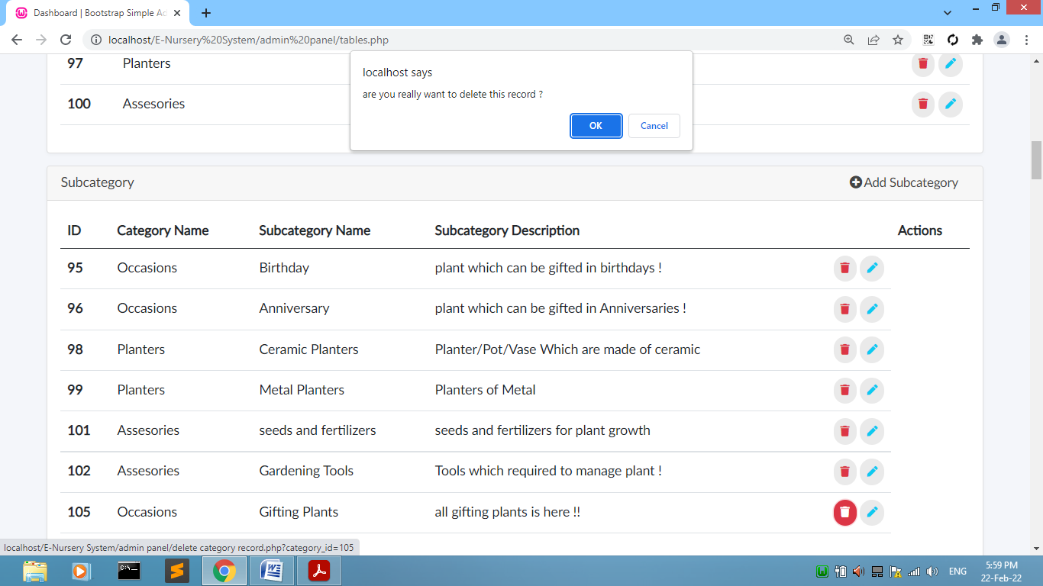

# [Figure: Subcategory Delete]

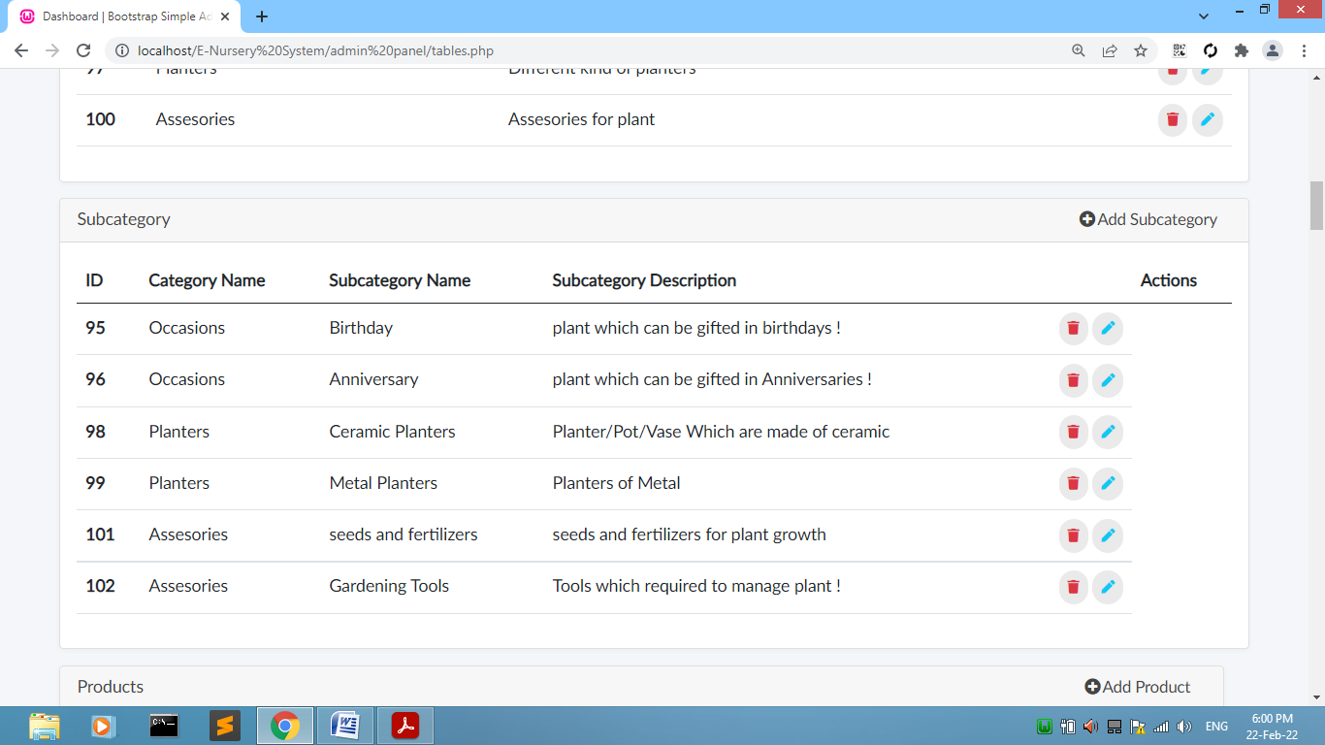

# [Figure: Subcategory Display]

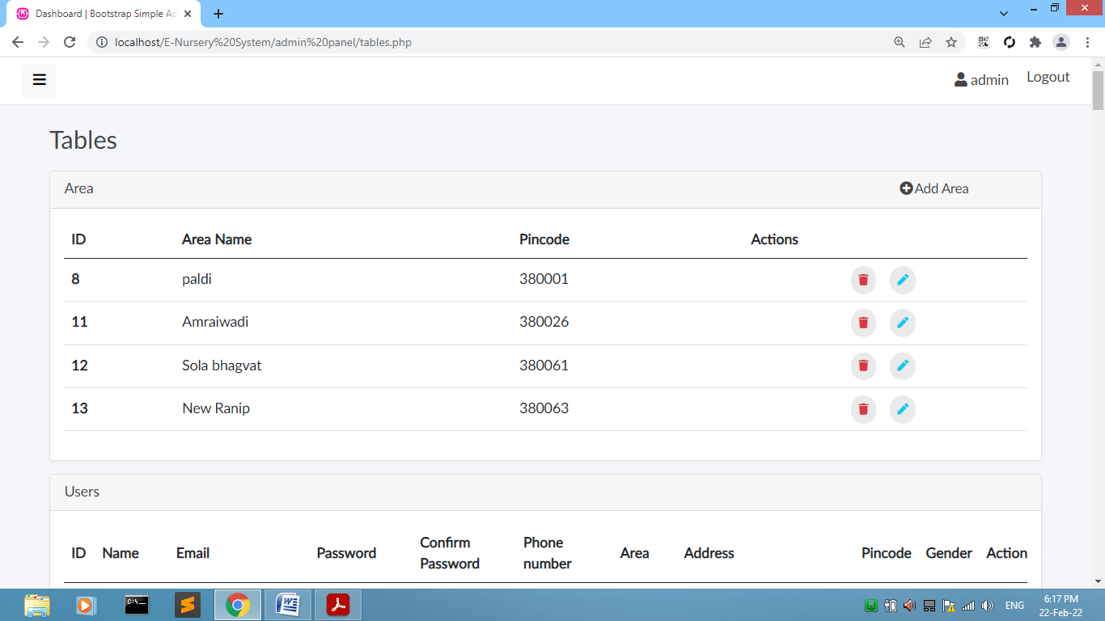

# [Figure: Area Table]

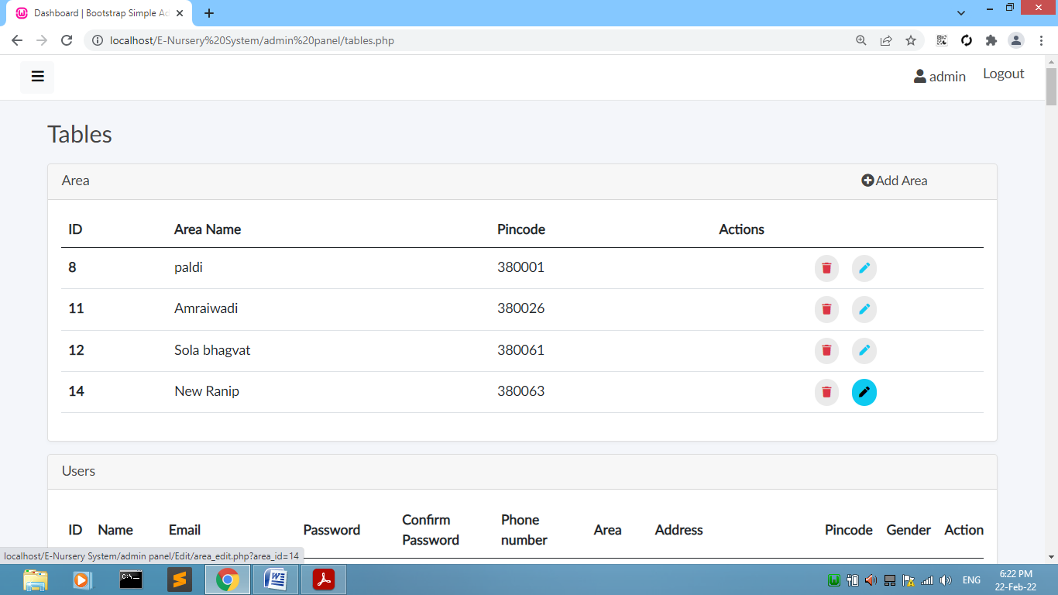

# [Figure: Area Edit]

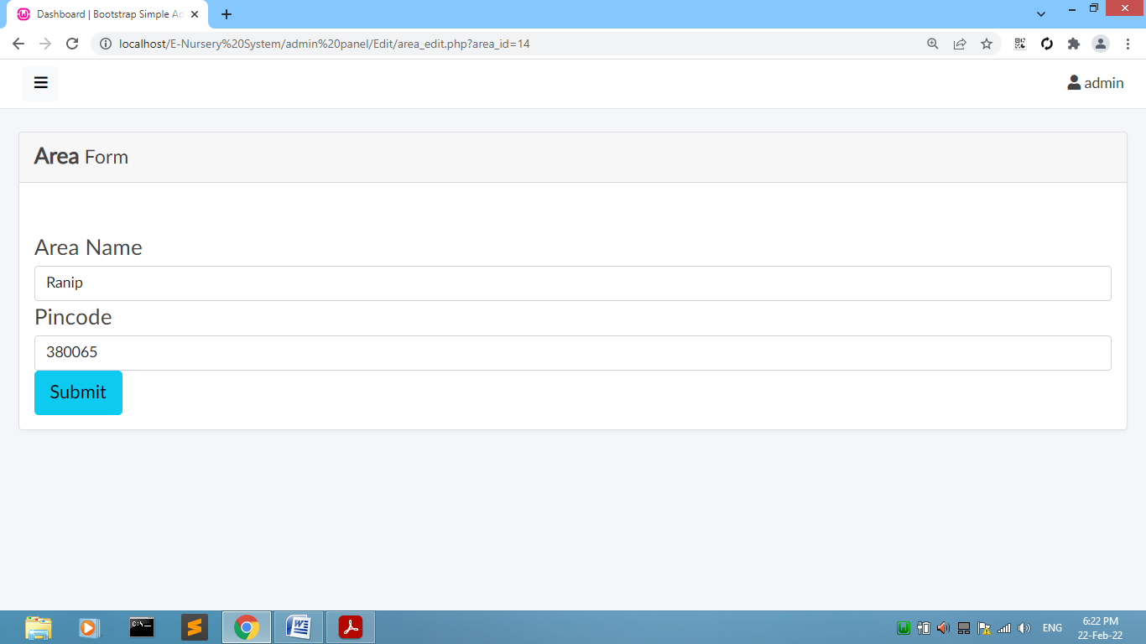

# [Figure: Area Edit Name or Pin code]

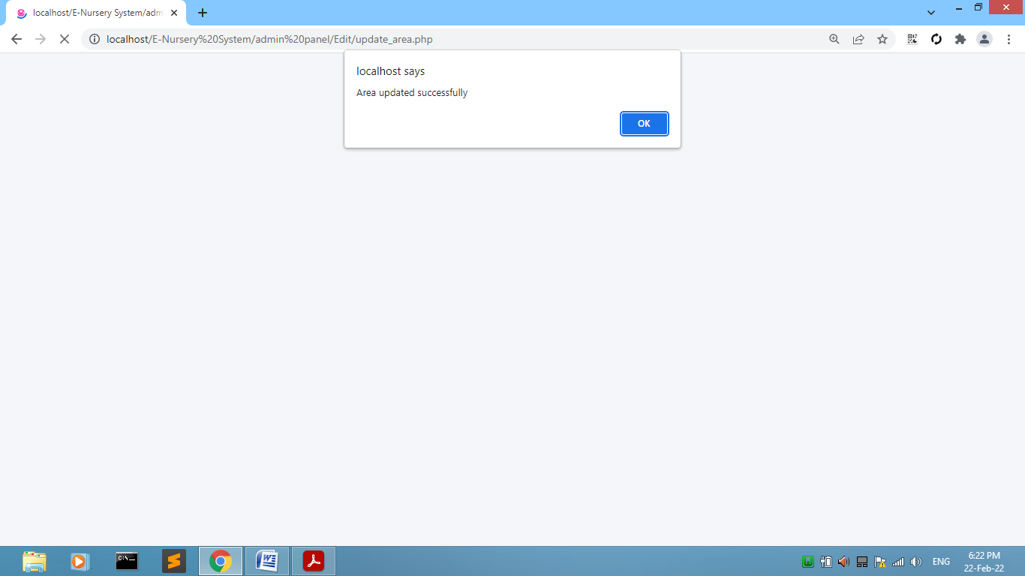

# [Figure: Area Edited Successfully]

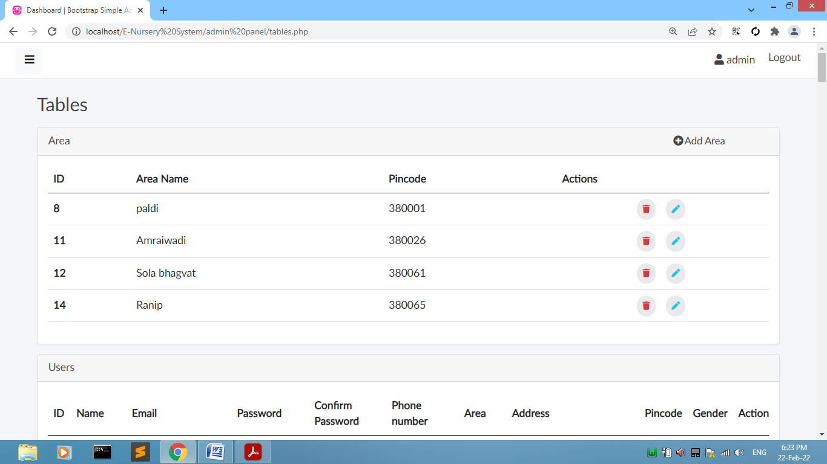

# [Figure: Area Display Edited]

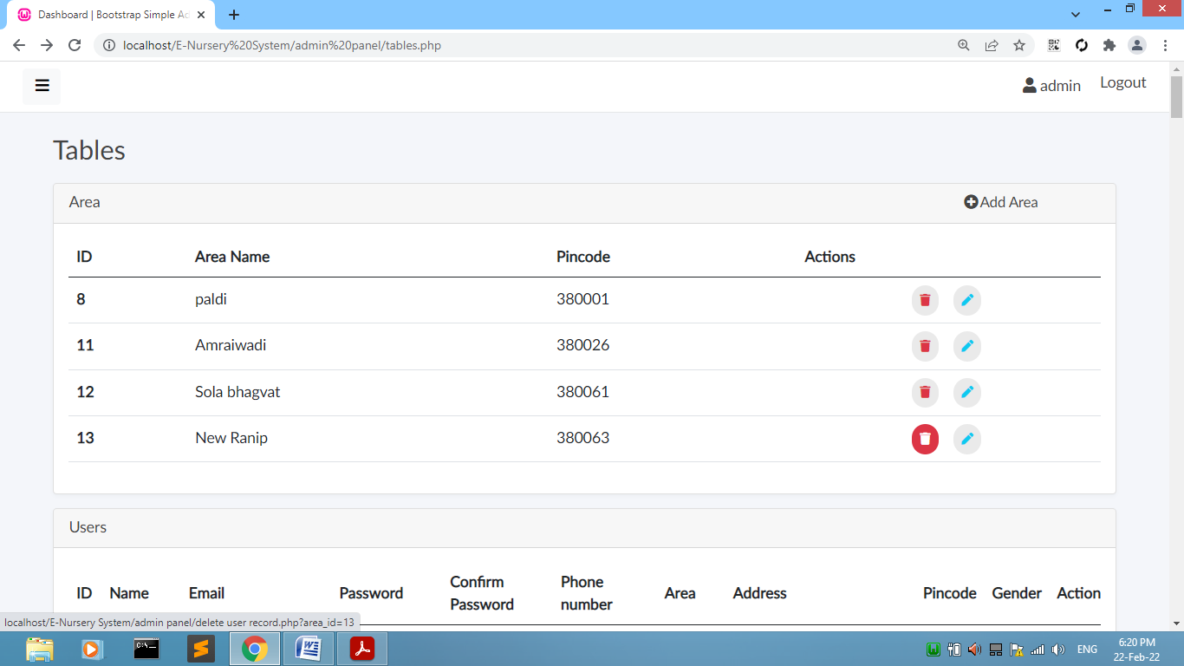

# [Figure: Area Delete]

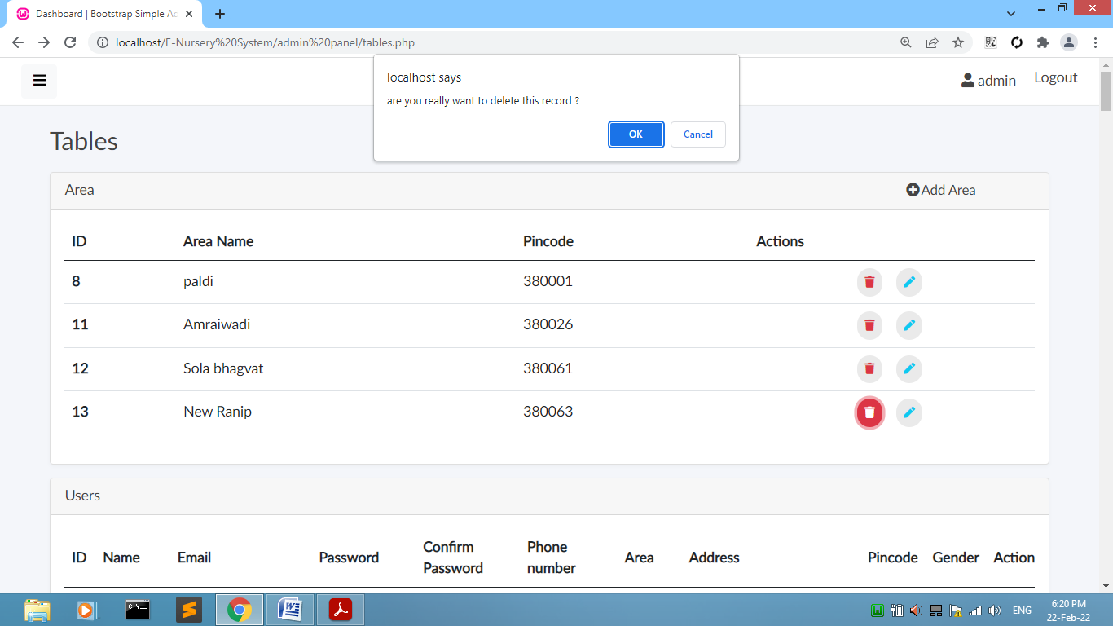

# [Figure: Area Delete]

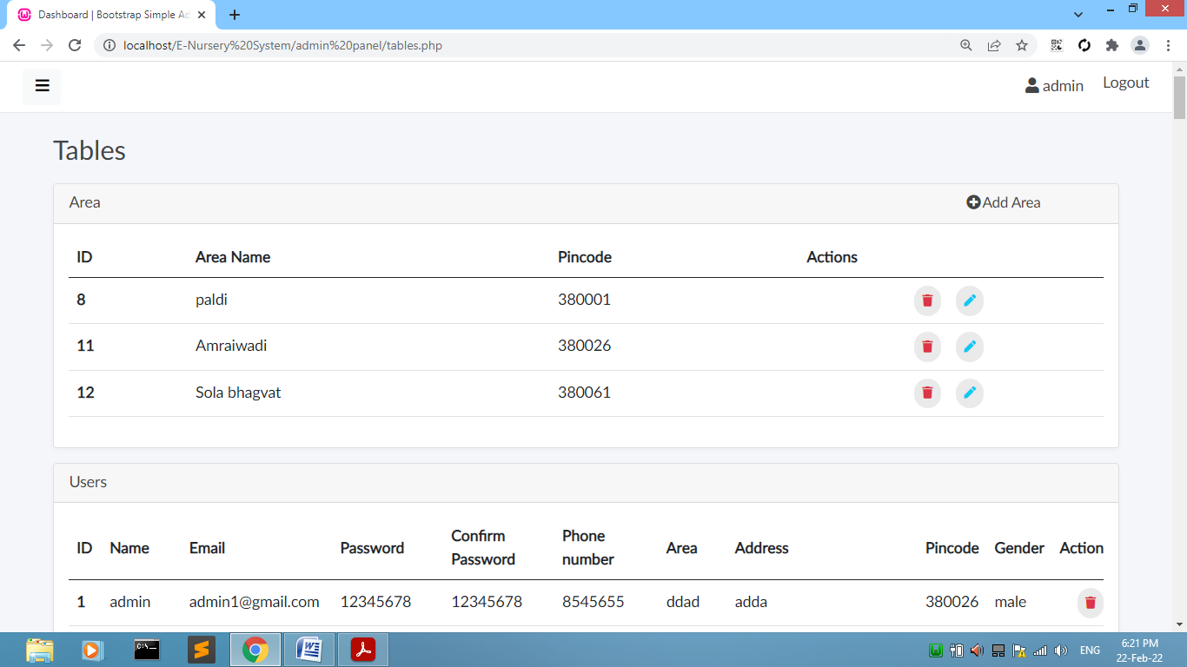

# [Figure: Area Display]

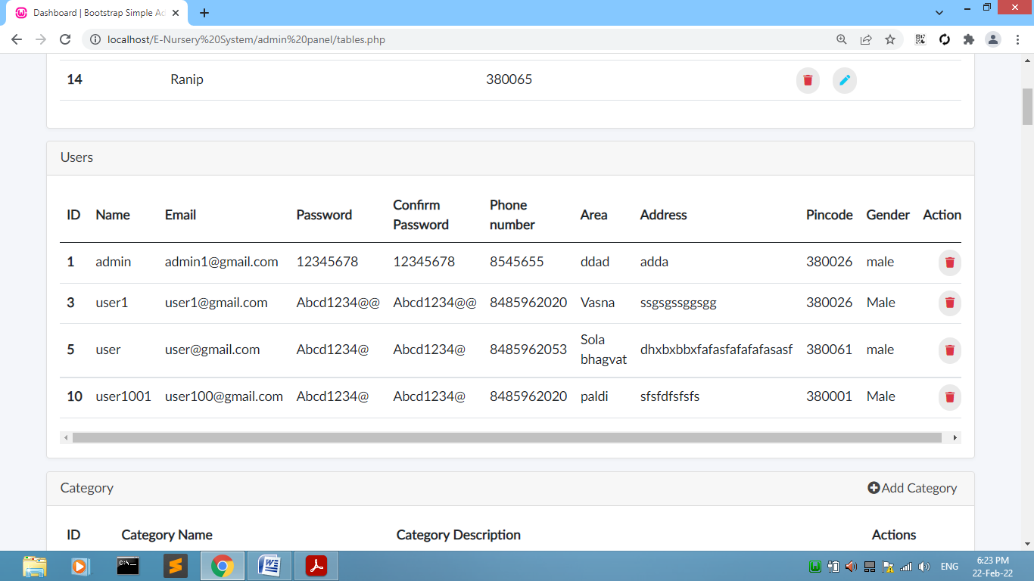

# [Figure: Users Table]

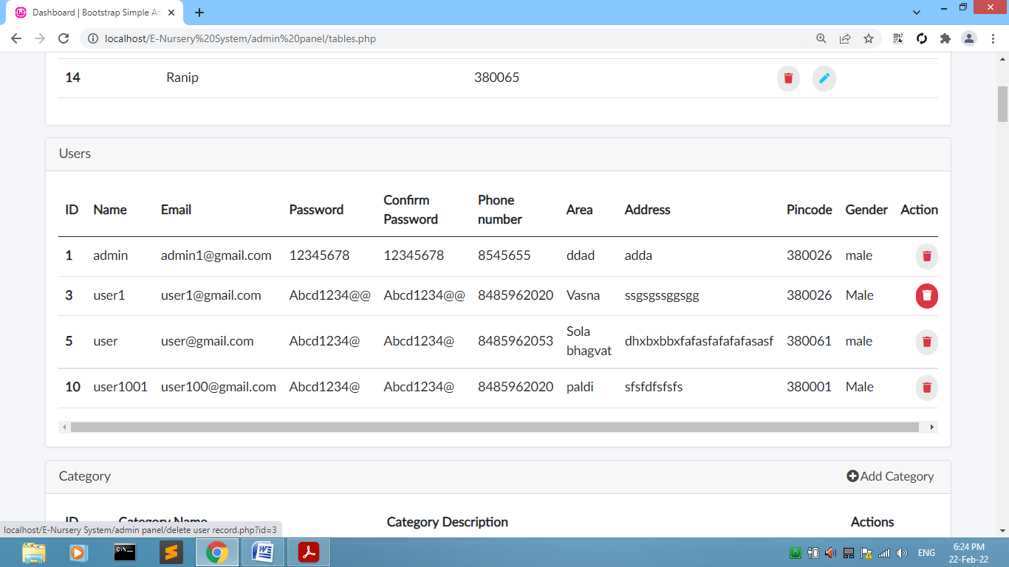

# [Figure: User Delete]

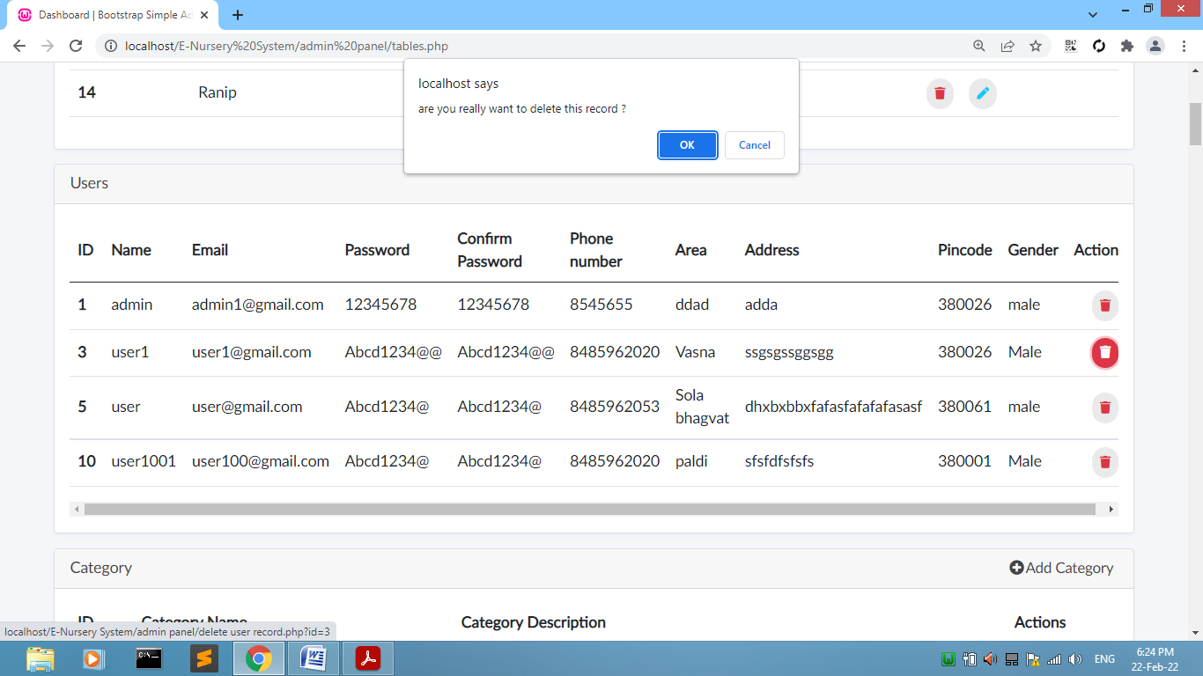

# [Figure: User Delete]

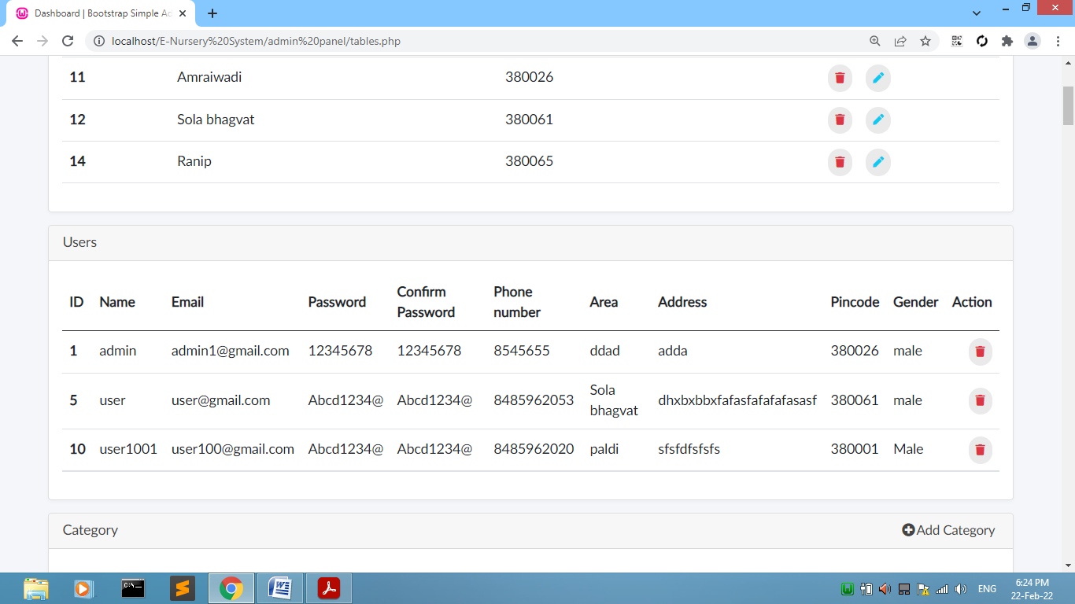

# [Figure: Users Display]

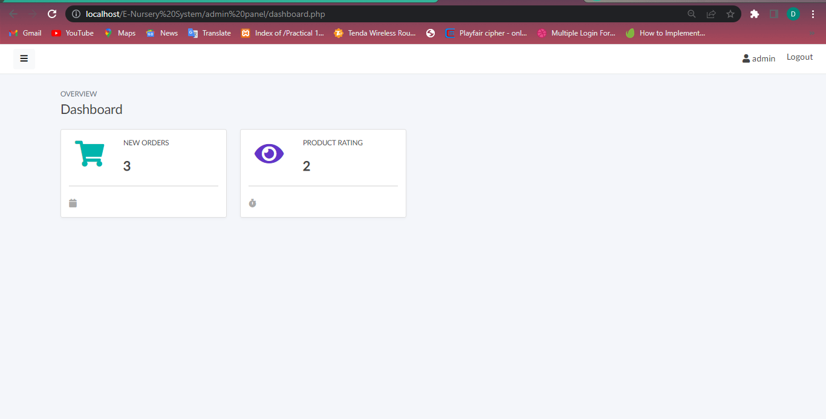

# [Figure: Dashboard]

**Managing Orders :-**

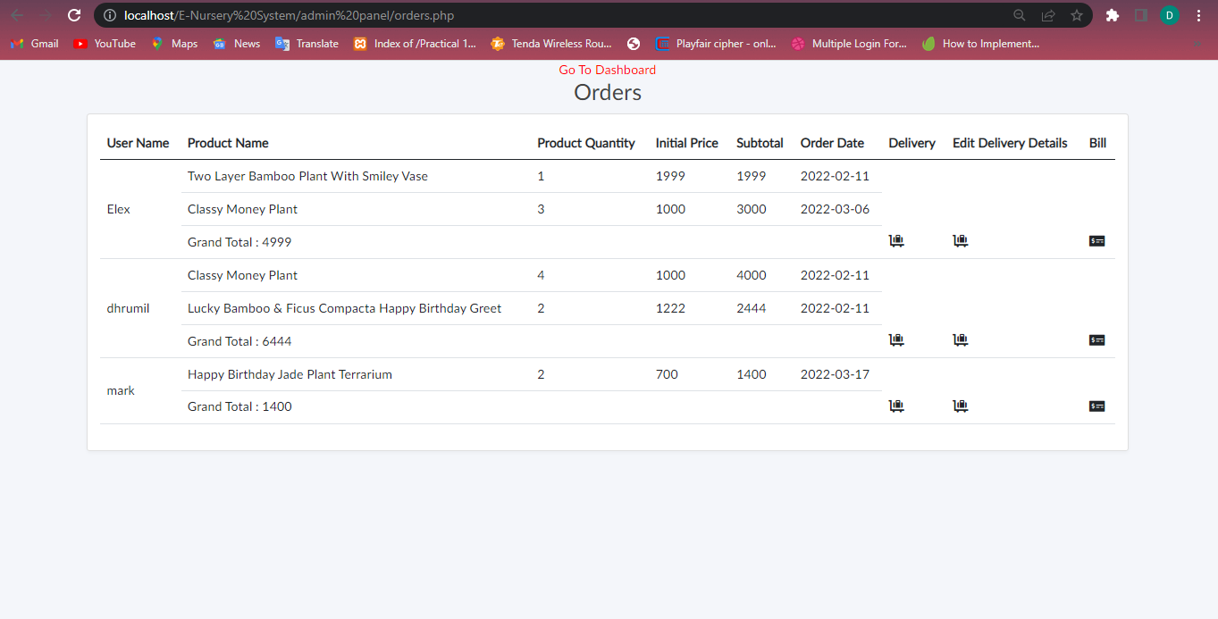

# [Figure: Orders of the customer]

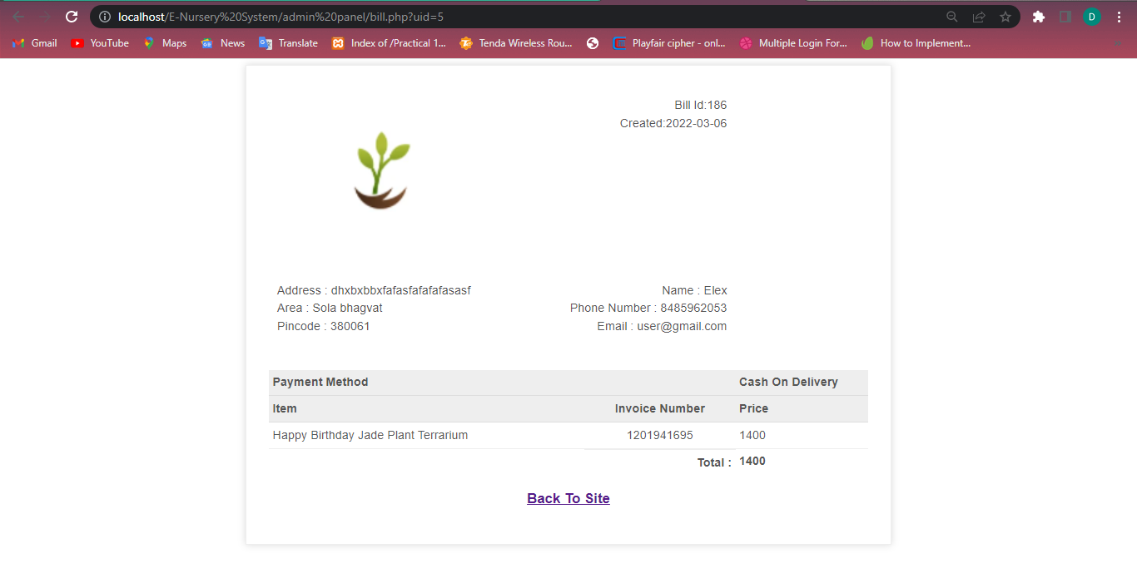

# [Figure: Bill of Elex]

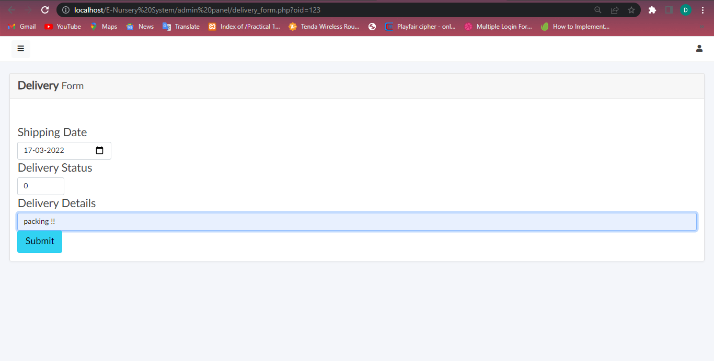

# [Figure: Delivery Details]

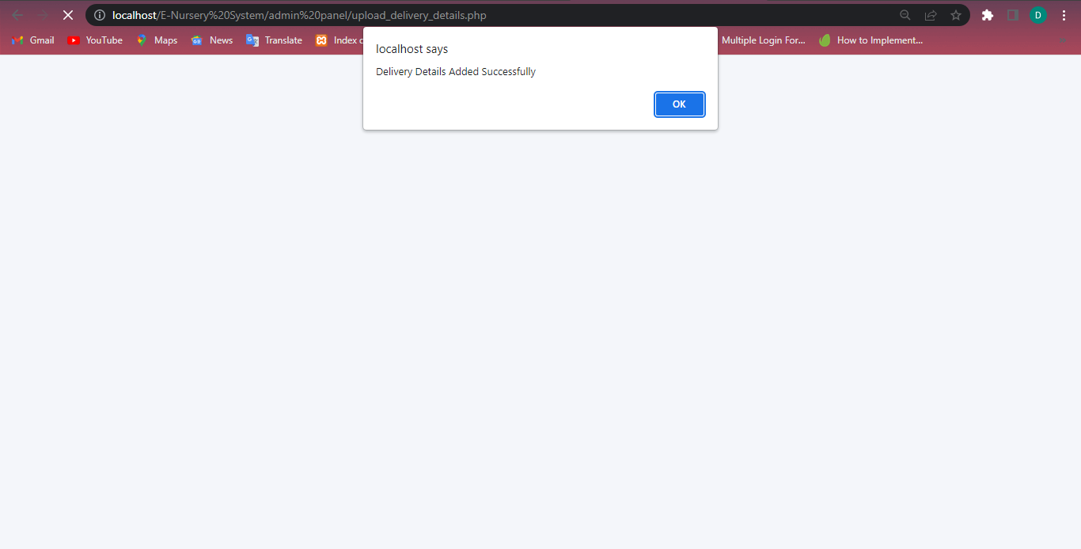

# [Figure: Delivery Details Added successfully]

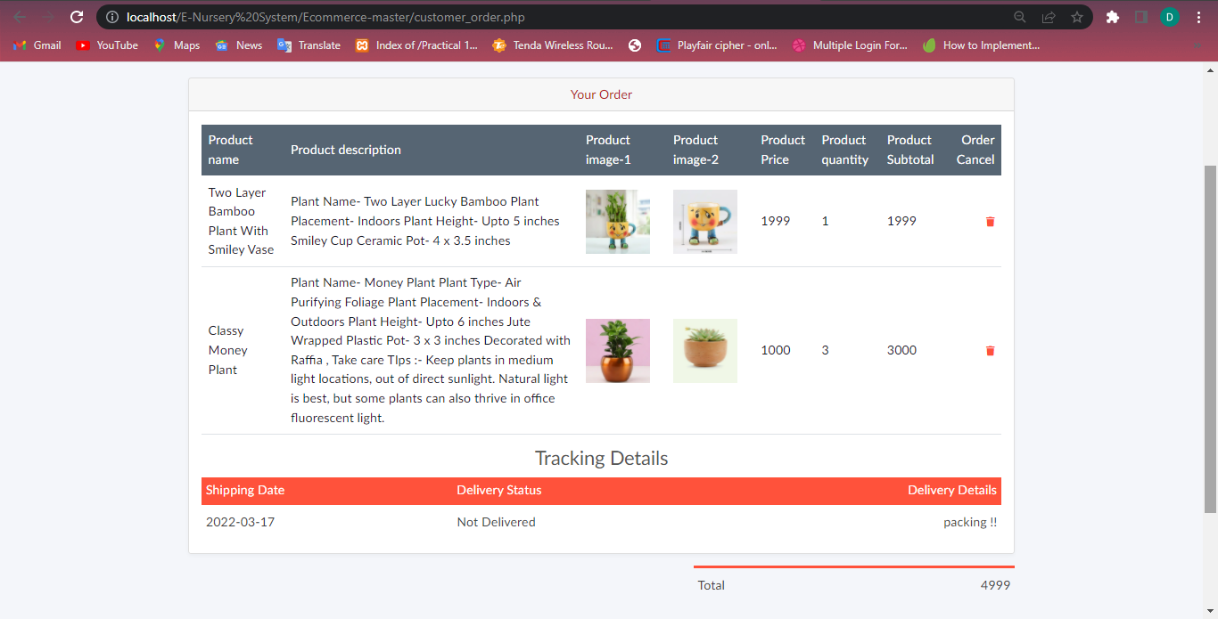

# [Figure: Delivery Details are displayed to user]

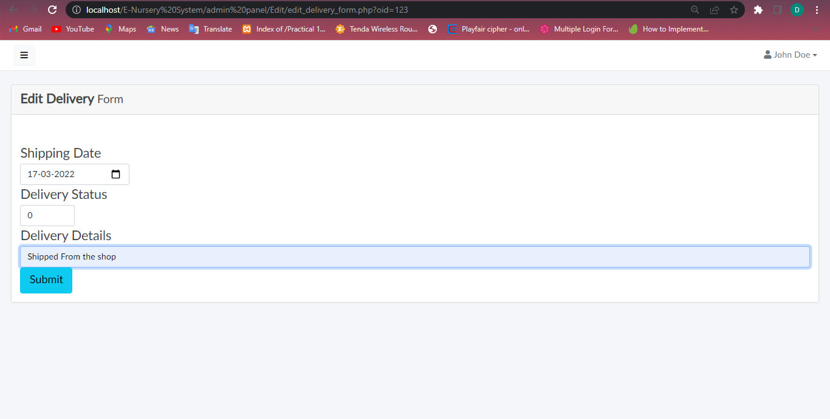

# [Figure: Updating Delivery Details]

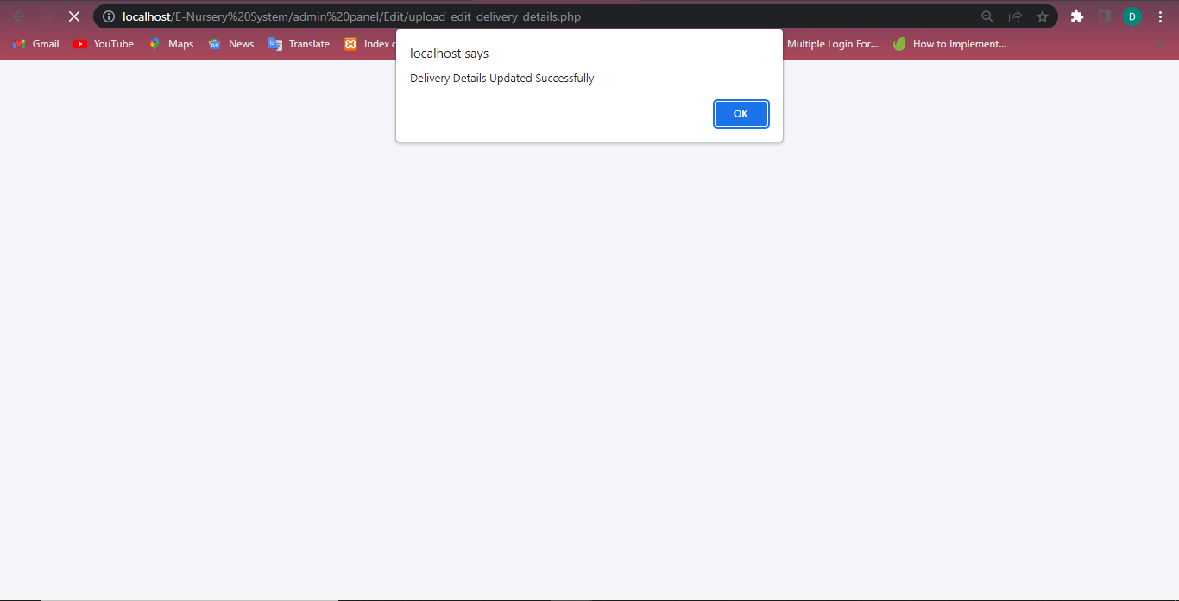

# [Figure: Delivery Details Updated Successfully]

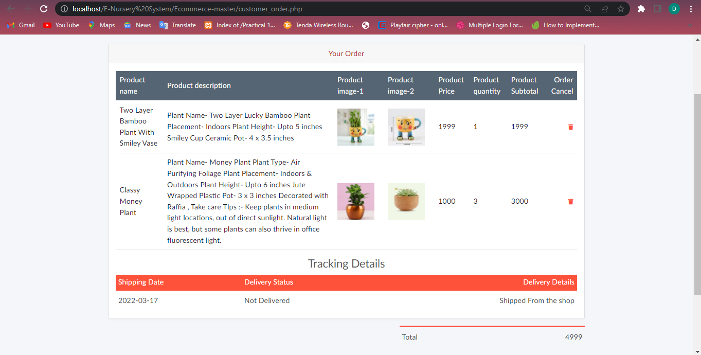

# [Figure: Updated delivery details will display to the user]

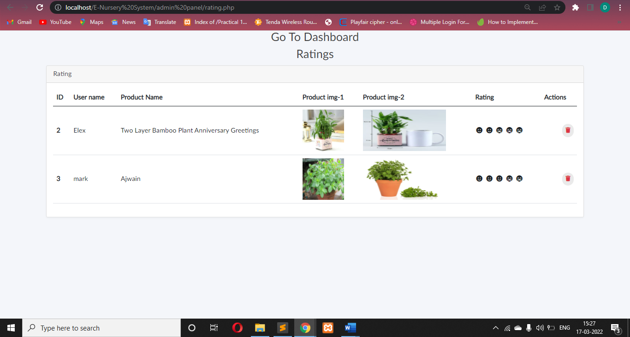

# [Figure: Rating Page]

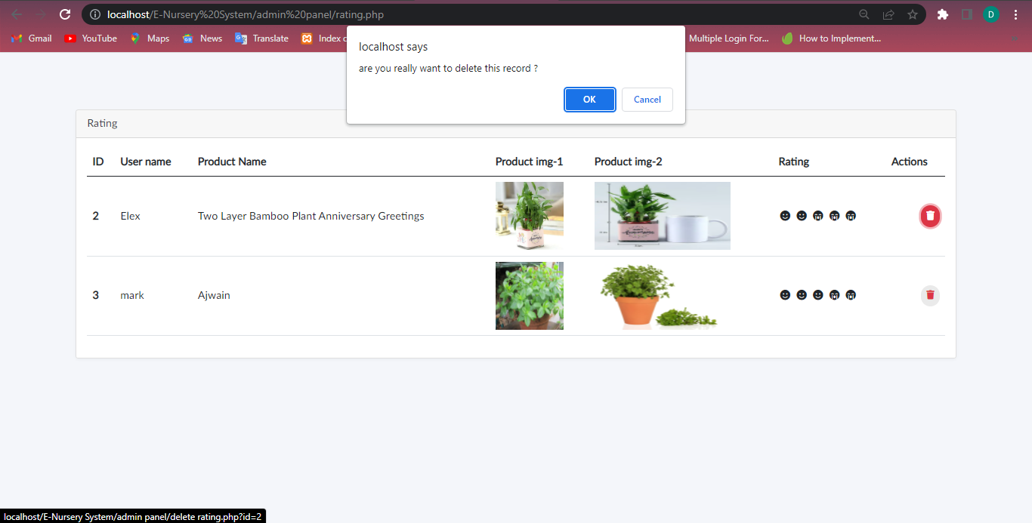

# [Figure: Delete Rating]

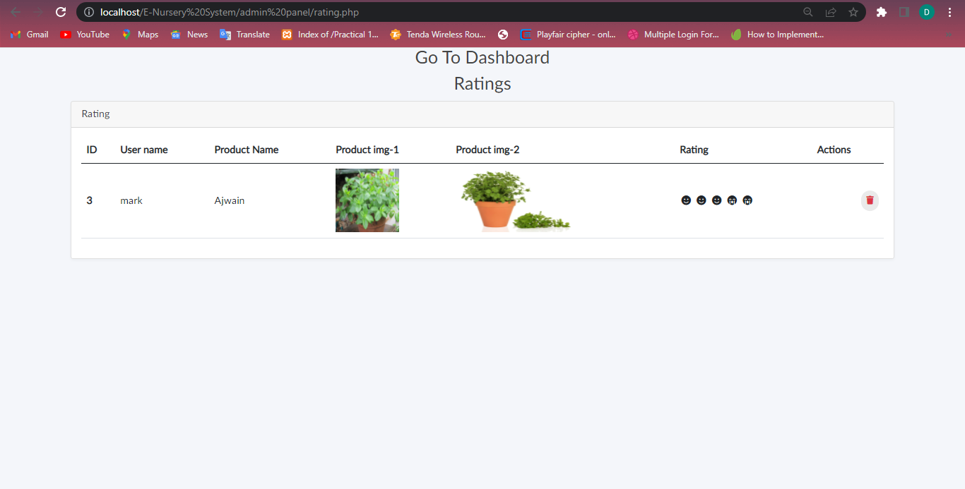

# [Figure: Rating Deleted]